

**INTRODUCTION TO INTERNET**

**PROGRAMMING**

**(PRG 4033)**

**PROJECT**

**SESSION: September 2024**

**Student Particulars**

|  |  |
| --- | --- |
| Name | : 1. Ahmad Faris Bin Mohamad Asri  2. Lee Chi Qi |
| Student Number | : 1. SCPG2300056  2. SCPG2300150 |
| Course Programme | : DIIT |
| Subject Title | : Introduction to Internet Programming |
| Subject Code | : PRG 4033 |
| Assignment Title | : website to book an appointment at a clinic |
| Name of Lecturer | : MS. ANIS NAZHIRAH BINTI MOHOD ZAHARI |
| Due Date | : 6th December 2024 |
| College | : Segi College Penang |

Table of Contents

1.0Introduction 4

1.1Problem Statement 4

1.3 Scope 4

1.4 Objective 4

1.5 Main Report 5

1.5.1Requirements Analysis 5

Functional Requirements 5

Non-Functional Requirements 5

1.5.2Initial sketch of the prototype 6

1.5.3 Suitable screenshots of the program in operation 11

1.5.4. New features added or strengths of code 58

1.5.5 Detail of any faults 65

1.6 Conclusion 66

1.7Peer Review 67

1.8References…………………………………………………………………………………………………………72

# 1.0Introduction

The assignment's main goal is to create a clinic's one-page landing page that allows patients to schedule appointments with physicians or other professionals. This system aims to guarantee effective appointment scheduling and management, expedite the appointment procedure, and enhance patient-administrator communication.  
  
The website will be made to function as a straightforward, easy-to-use platform for patients to schedule appointments, guaranteeing that the clinic administrator is notified via email of the required booking information. Additionally, it will offer interactive design features, show and validate input fields, and remain responsive across various devices.

# 1.1Problem Statement

The clinic faces challenges in managing patient appointments efficiently, resulting in potential delays, miscommunication, and inconvenience for both patients and administrators. The lack of a streamlined online system for scheduling appointments necessitates an improved digital solution that facilitates effective communication, automates notifications, and ensures accurate data collection.

# 1.3 Scope

Scheduling clinic appointments will be centralized on the one-page home page. To choose available times, dates, and practitioners for their appointments, patients will utilize the website. In order to efficiently manage and coordinate schedules, the clinic administrator will get booking data via email upon submission.

# 1.4 Objective

This assignment is to design and develop a one-page landing page for the clinic. This page will serve as a user-friendly platform enabling patients to schedule appointments with physicians or other professionals seamlessly. The system aims to:

1. Provide an intuitive platform for patients to schedule appointments.
2. Ensure clinic administrators receive booking details via email promptly.
3. Include a clean, aesthetically pleasing design that is responsive across devices.
4. Offer a seamless experience with interactive navigation and validated form inputs.

# 1.5 Main Report

## 1.5.1Requirements Analysis

### Functional Requirements

1. Users Registration and Appointment Scheduling:

Allow patients to enter information about themselves, including their name, phone number, email address, preferred date, time, and purpose for visiting.  
Verify user input (e.g., phone number length, email format, and absence of blank fields).

1. Notifications from the Administrator:  
   Upon submission, automatically send the administrator an email with the appointment information.
2. Design that is responsive:  
   Make sure the landing page works flawlessly on PCs, tablets, and smartphones and is completely responsive.
3. Confirmation of Appointment:  
   After a successful booking, give patients instant confirmation.

### Non-Functional Requirements

1. Performance:

Ensure the system processes form submissions and sends email notifications within 5 seconds.

1. Security:

Protect user data with HTTPS for secure communication.

Restrict email handling to trusted servers.

1. Reliability:

Ensure up-time availability of booking services.

1. Accessibility:
2. Use web accessibility standards to make the page usable for individuals with disabilities.

## 1.5.2Initial sketch of the prototype

Registration and Login of patient

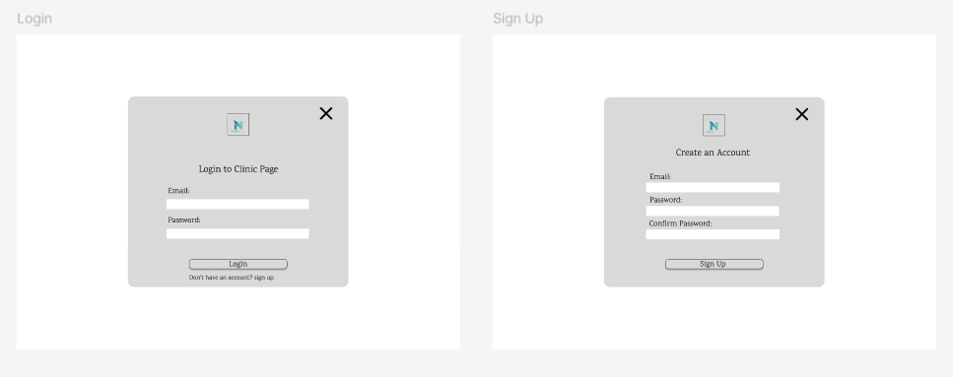

Login Page

The email needs to be inputted into the field where users registered email address. Password also needs to input field for entering their account passwordA link below the button saying, *"Don't have an account? Sign up,"* which directs users to the Sign Up modal or page.

Sign Up login

The email needs to be inputted into the field where users registered email address. Password also needs to input field for setting a password. The confirm password is input field to re-enter the password for validation.

Patient

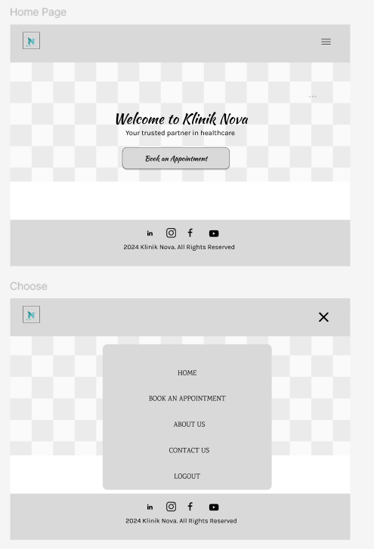

The homepage features a welcoming message and a prominent "Book an Appointment" call-to-action, guiding users toward the site's primary function. A minimalist layout ensures focus, complemented by easy navigation through a hamburger menu. This menu reveals key sections such as Home, Book an Appointment, About Us, Contact Us, and Logout, ensuring all essential features are accessible without overwhelming the user. Footer elements, including social media links and copyright details, enhance connectivity and professionalism, while the overall design prioritizes accessibility and clarity.

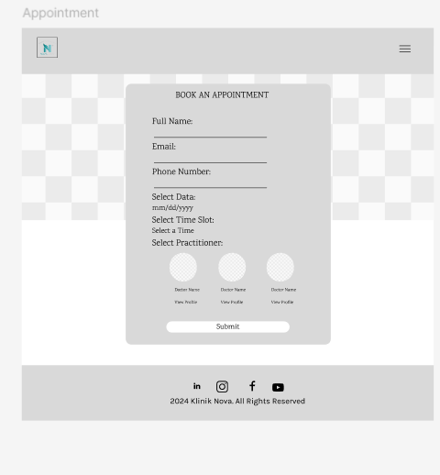

Book Appointment pages have been needed to tag your information detail. The patient can choose the time and date. This also can choose your like a practitioner and see the practitioners a view profile. The patient to click the submit is confirm your choosing and take the booking an appointment.

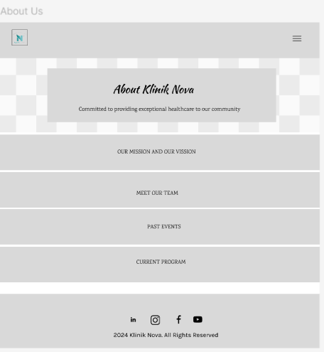

About Us Pages show our imagination like Our Mission definition of the company's business, who it serves, what it does, its objectives, and its approach to reaching those objectives; A Vision Statement is a description of the desired future state of the company; Meet Our Team; Past Events; and Current Program.

Contact Us Pages have two parts (Contact Us and Contact Patient). Contact Us shows Contact Information. Contact Patient is input field the Full Name, Email. If you have any medical report can upload.

Admin

Login Page

The email needs to be inputted into the field where users registered email address. Password also needs to input field for entering their account passwordA link below the button saying, *"Don't have an account? Sign up,"* which directs users to the Sign Up modal or page.

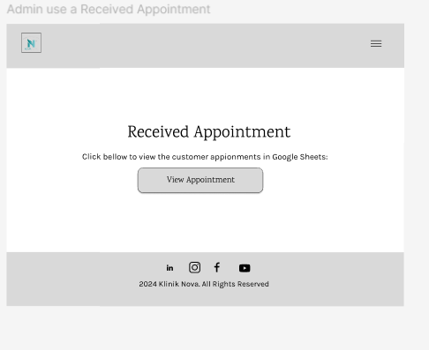

Admin using a received Appointment pages can click the View Appointment. The View Appointment shows the patient take an appointment in Google Sheets.

## 1.5.3 Suitable screenshots of the program in operation

Patient part

Home.html

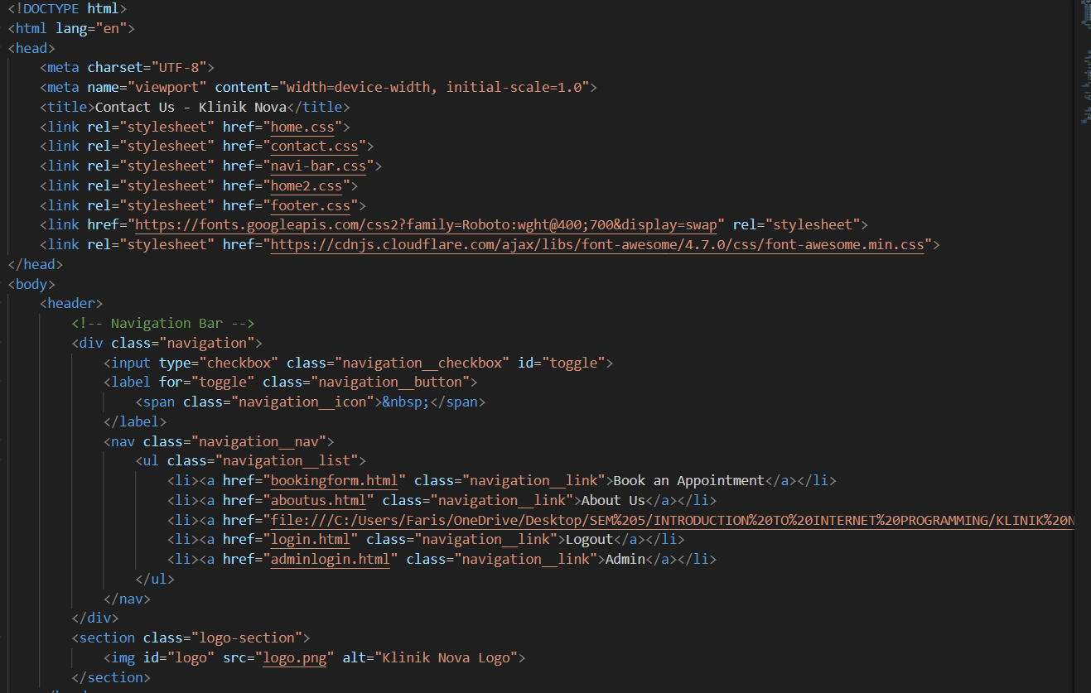

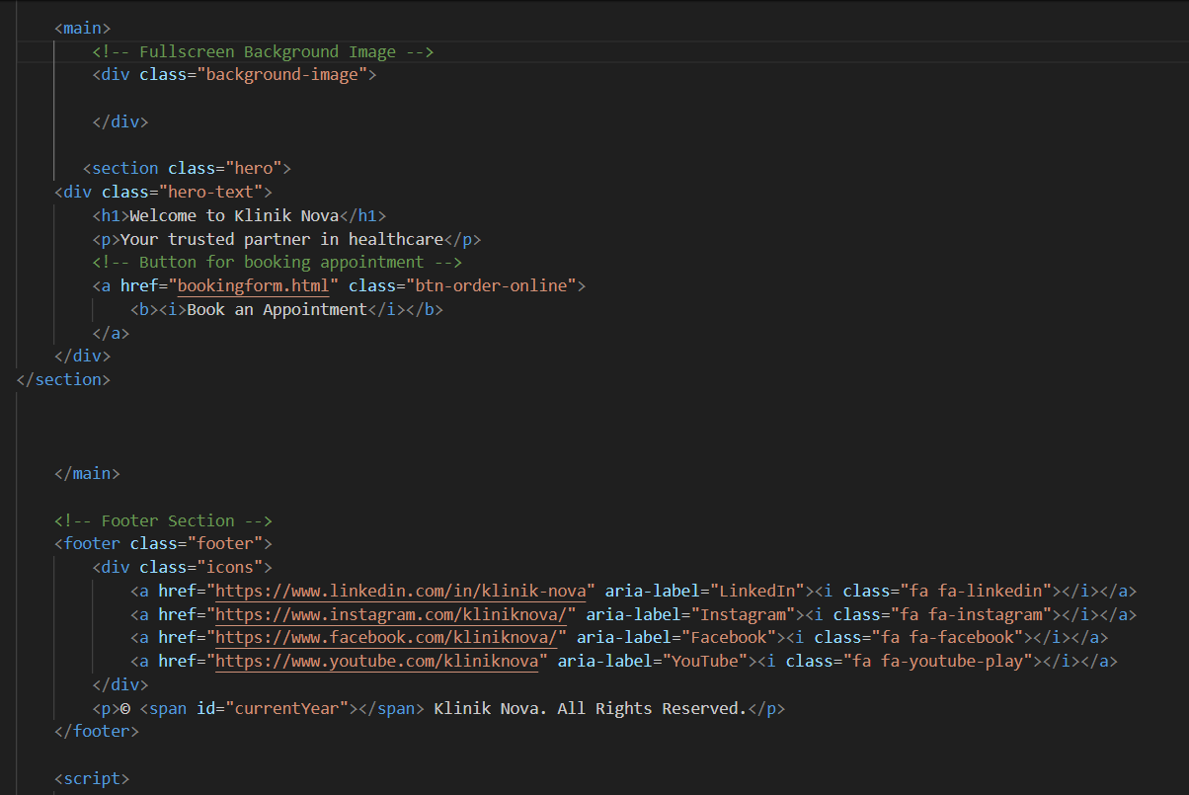

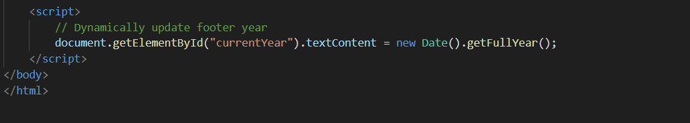

Homepage.css

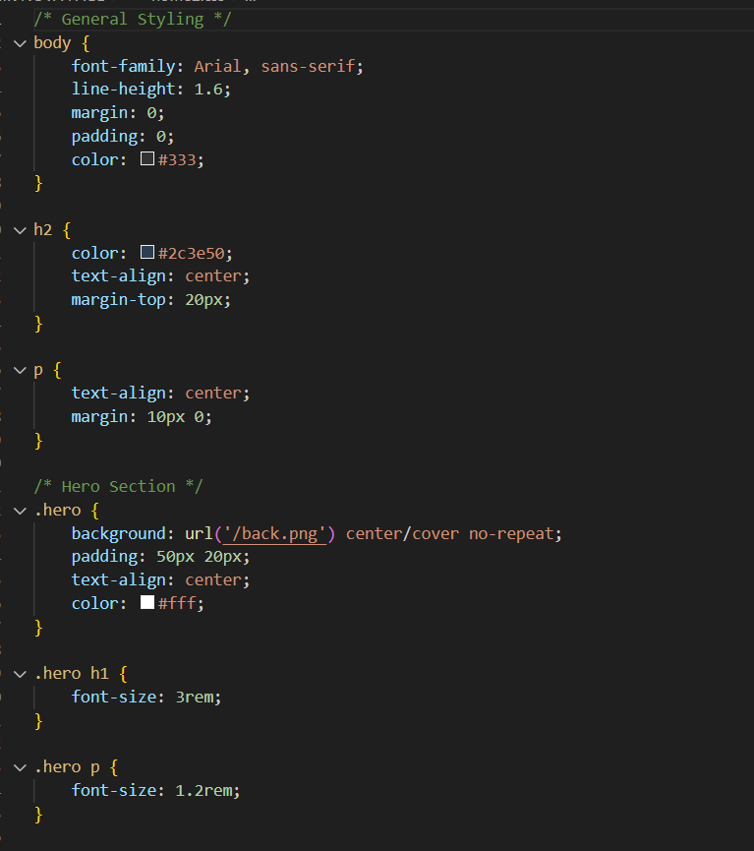

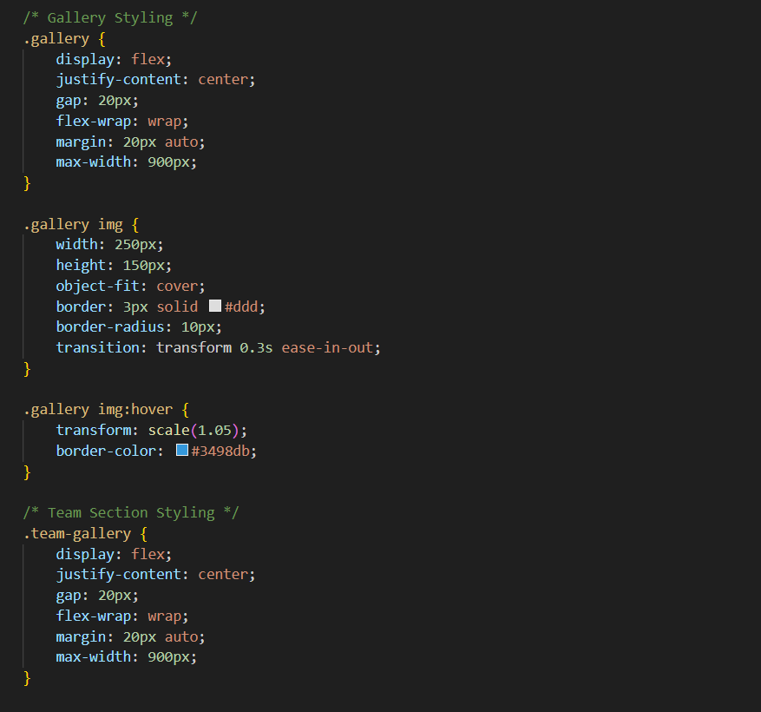

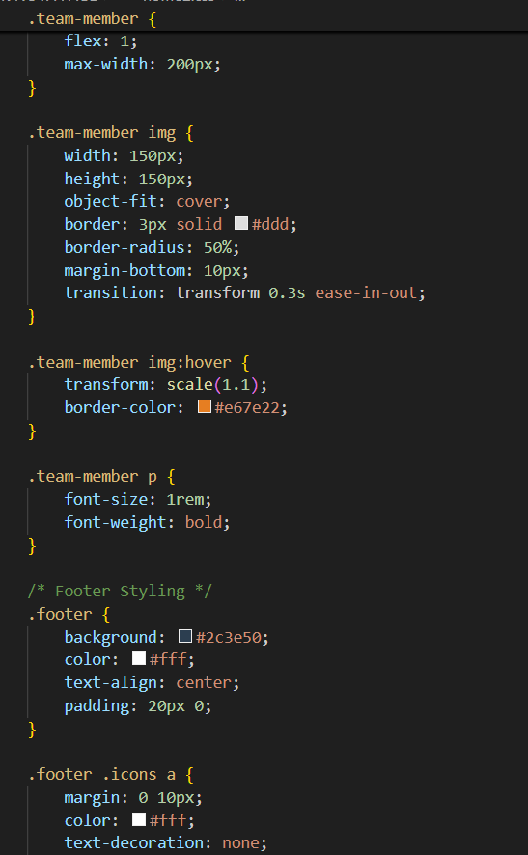

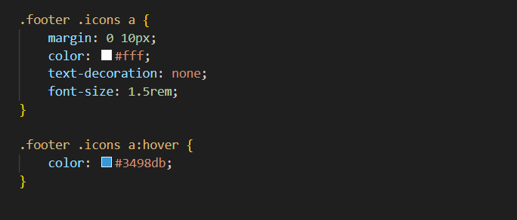

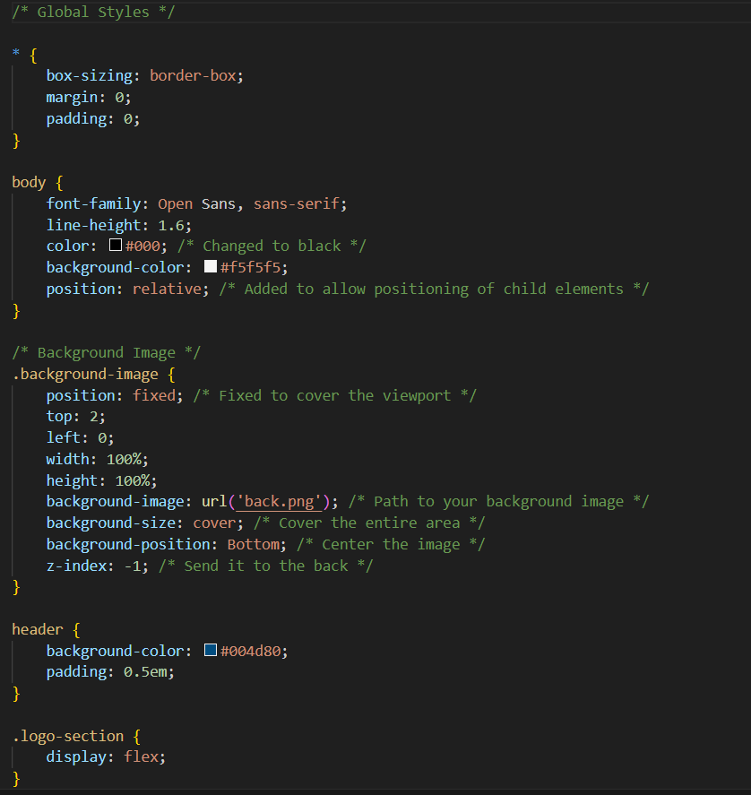

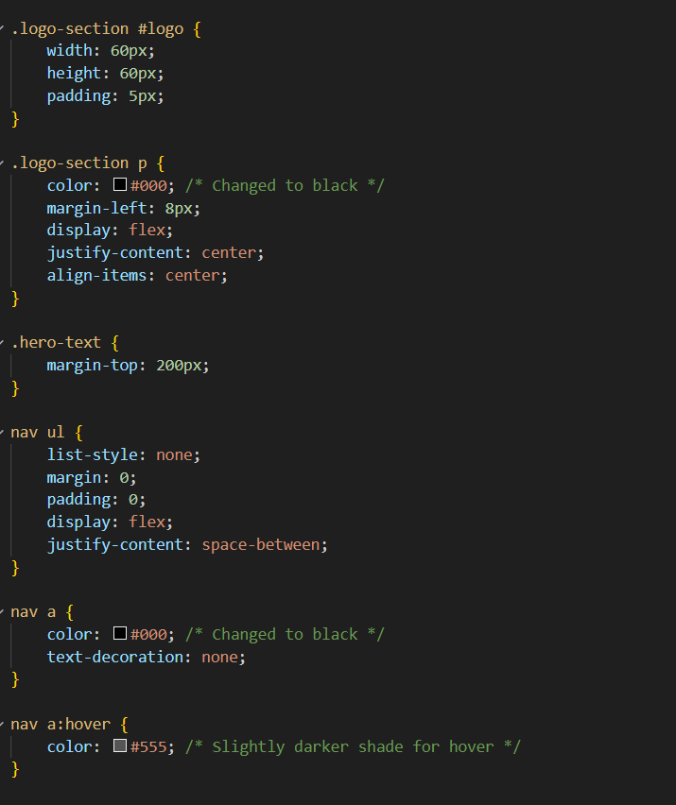

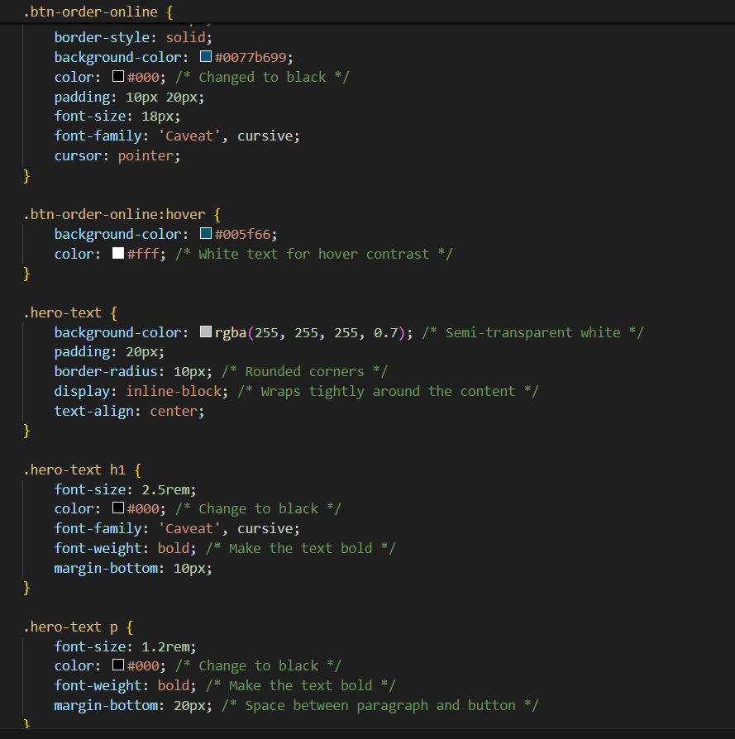

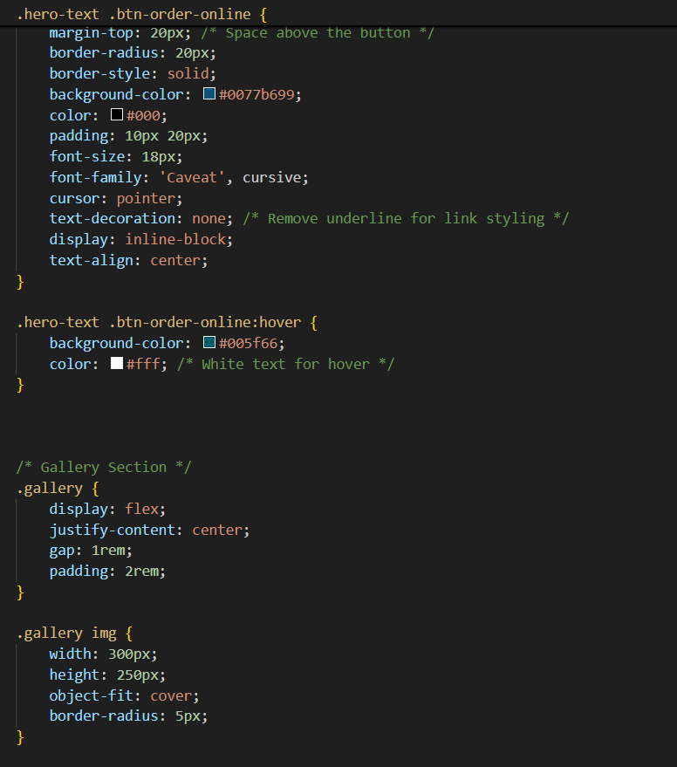

Appointment.html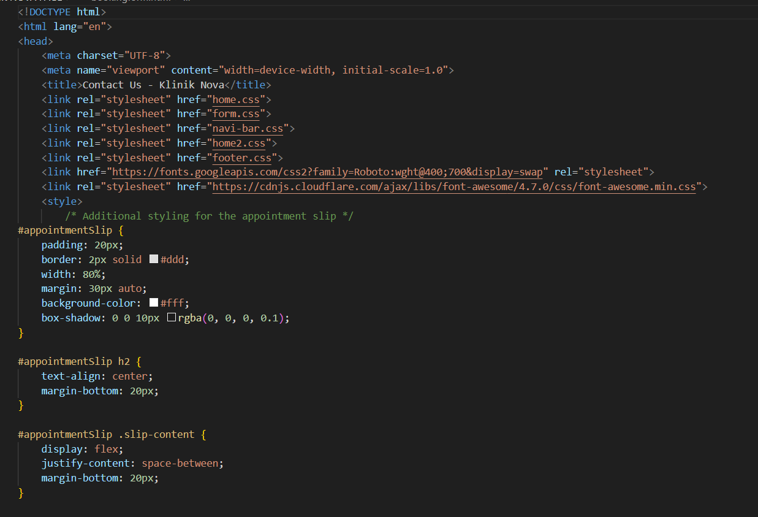

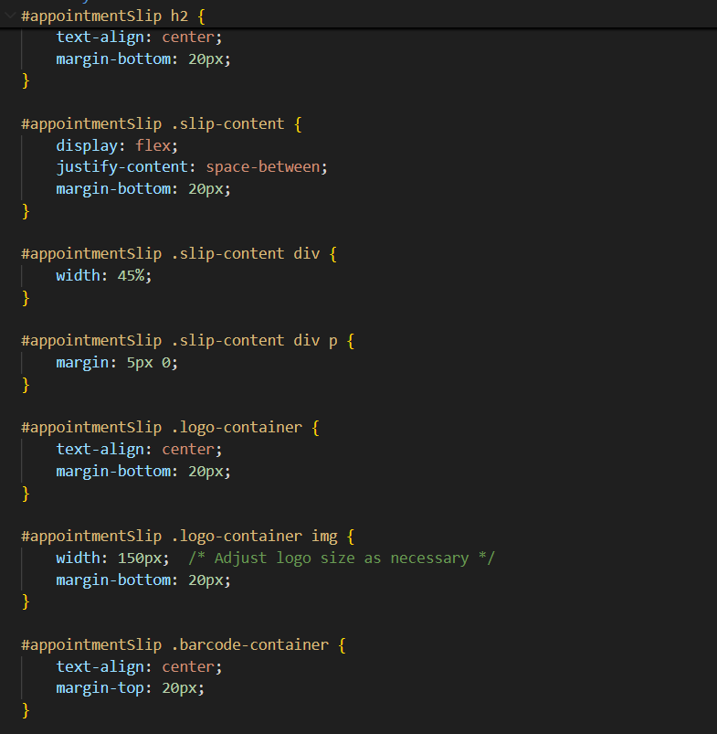

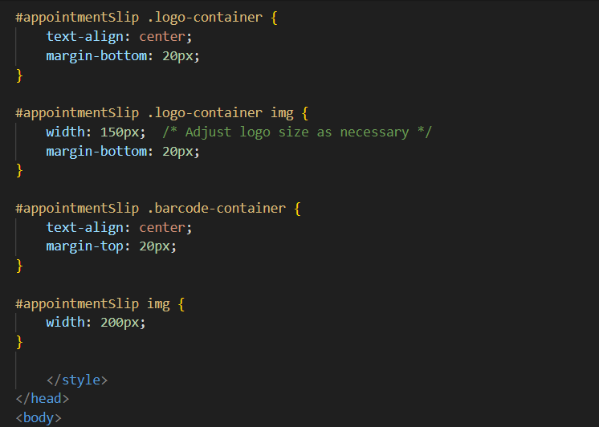

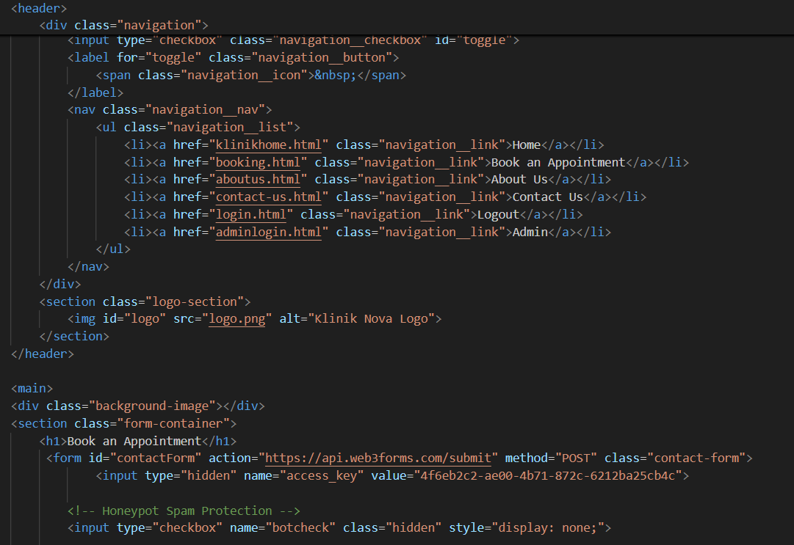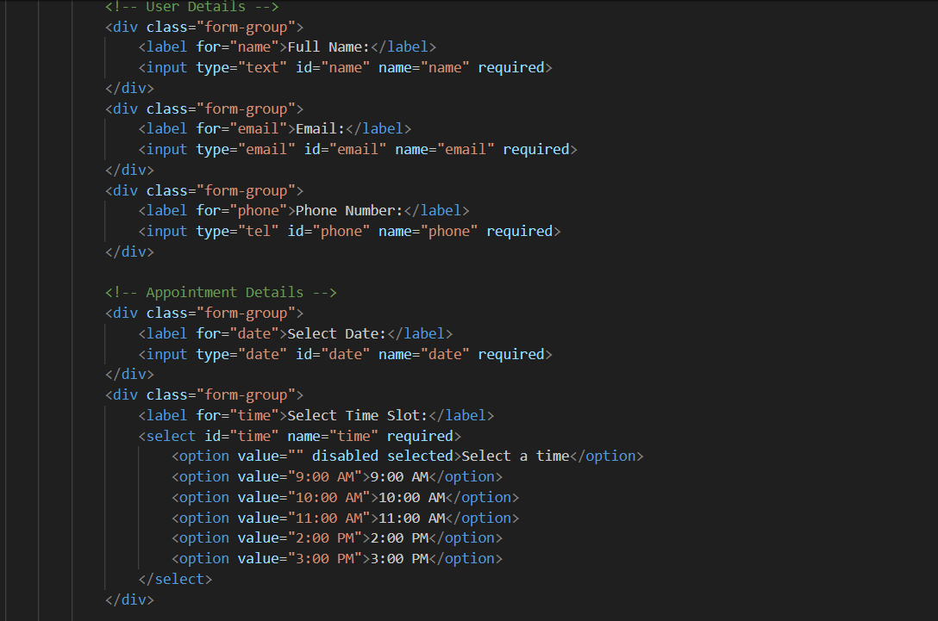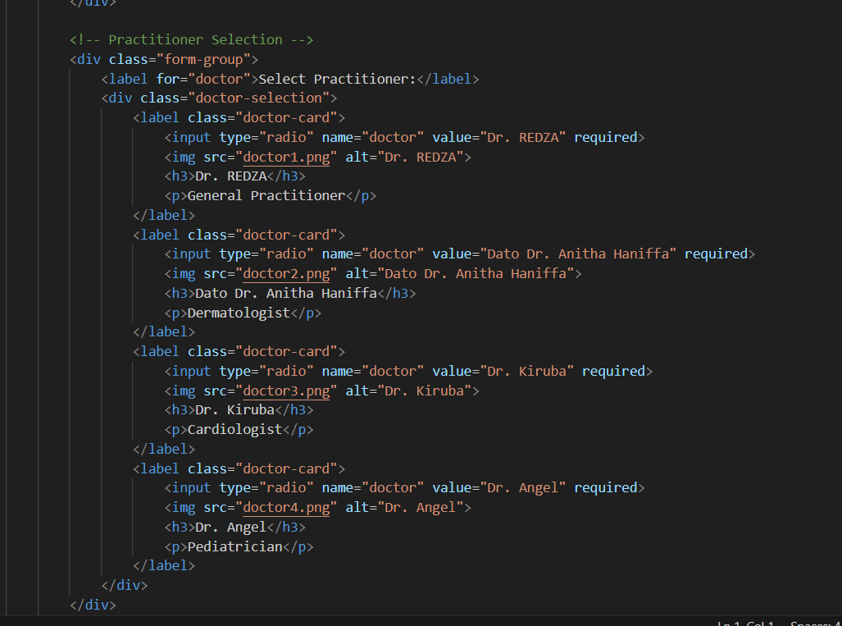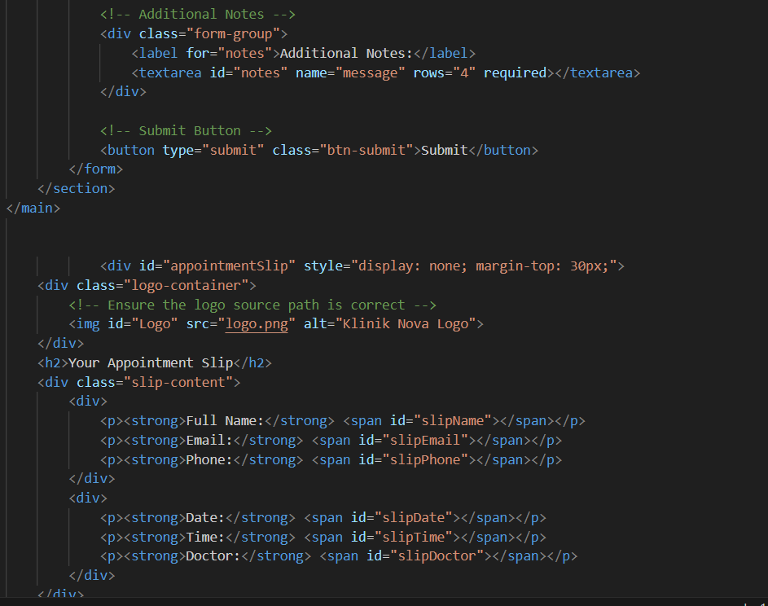

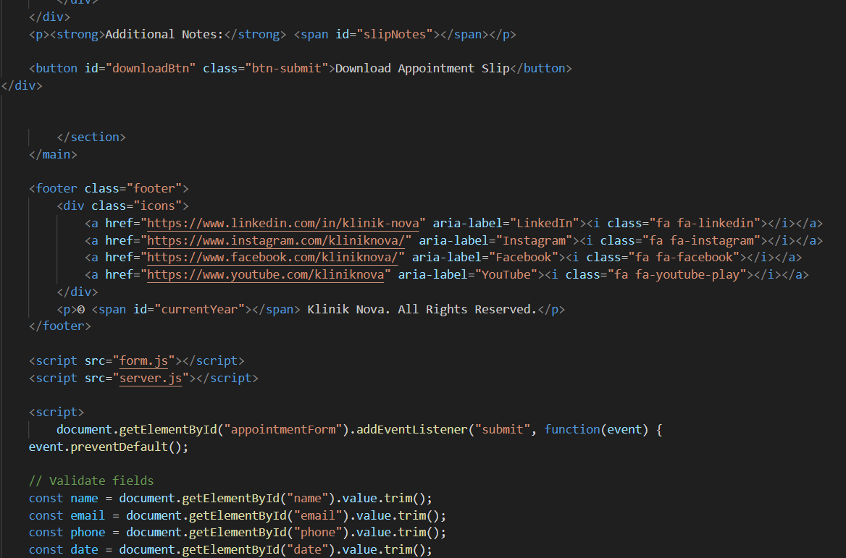

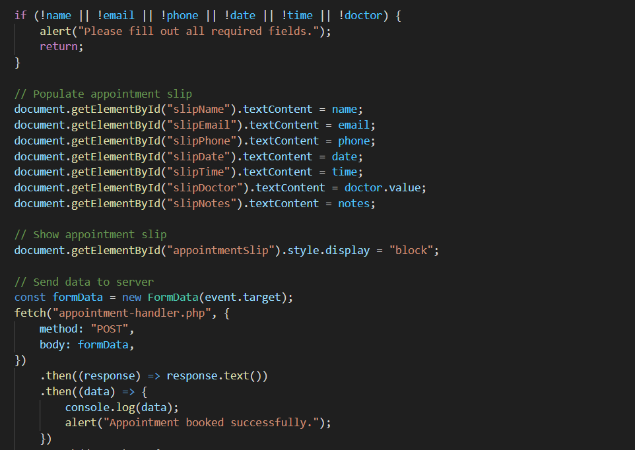

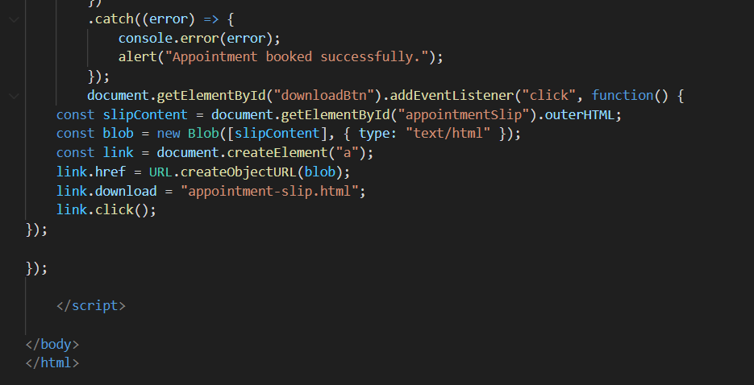

Contract page.html

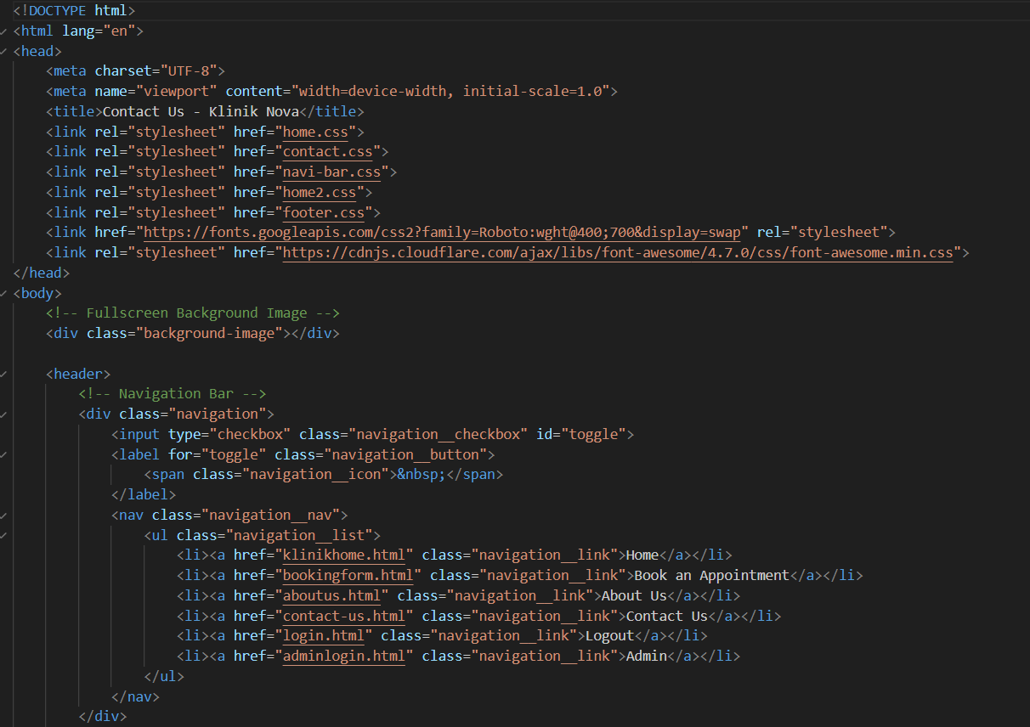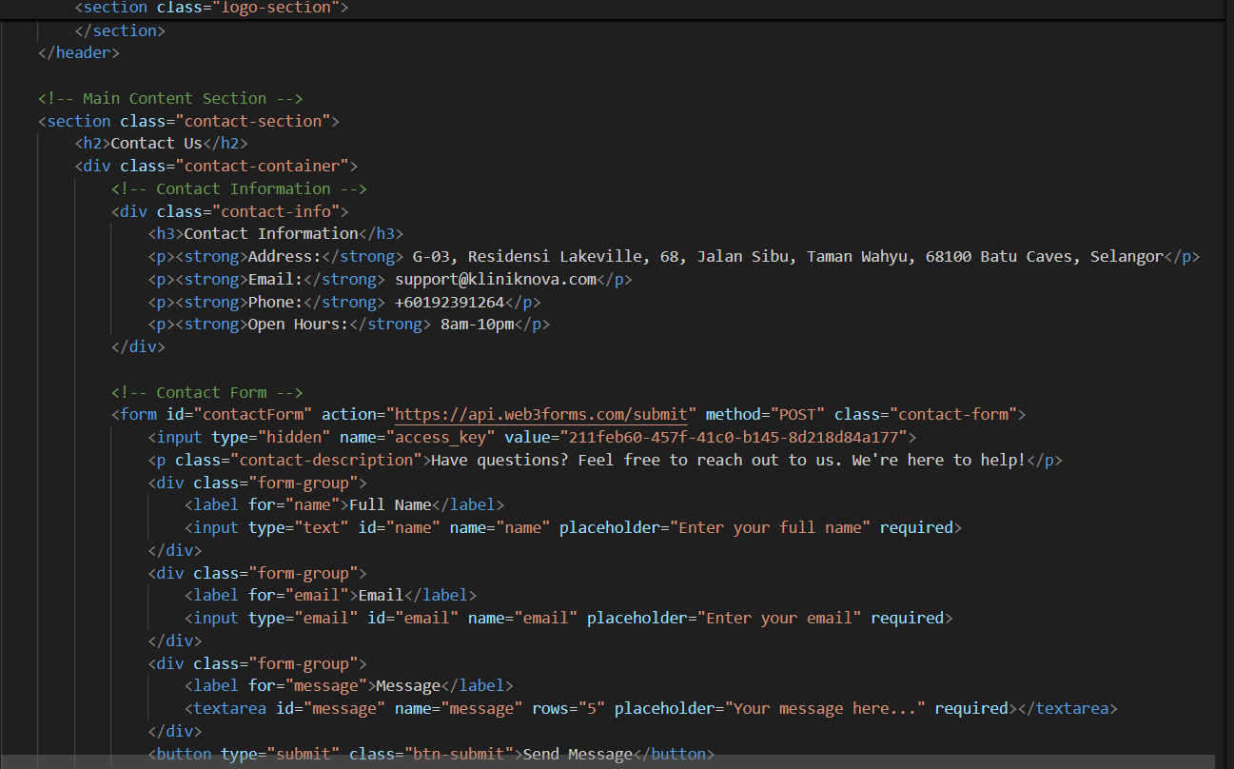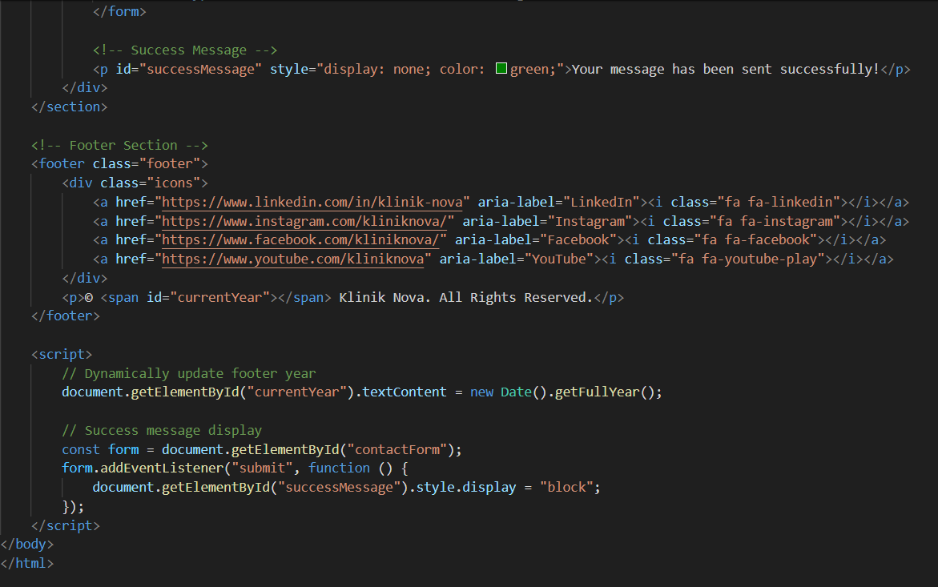

Contact Us.css

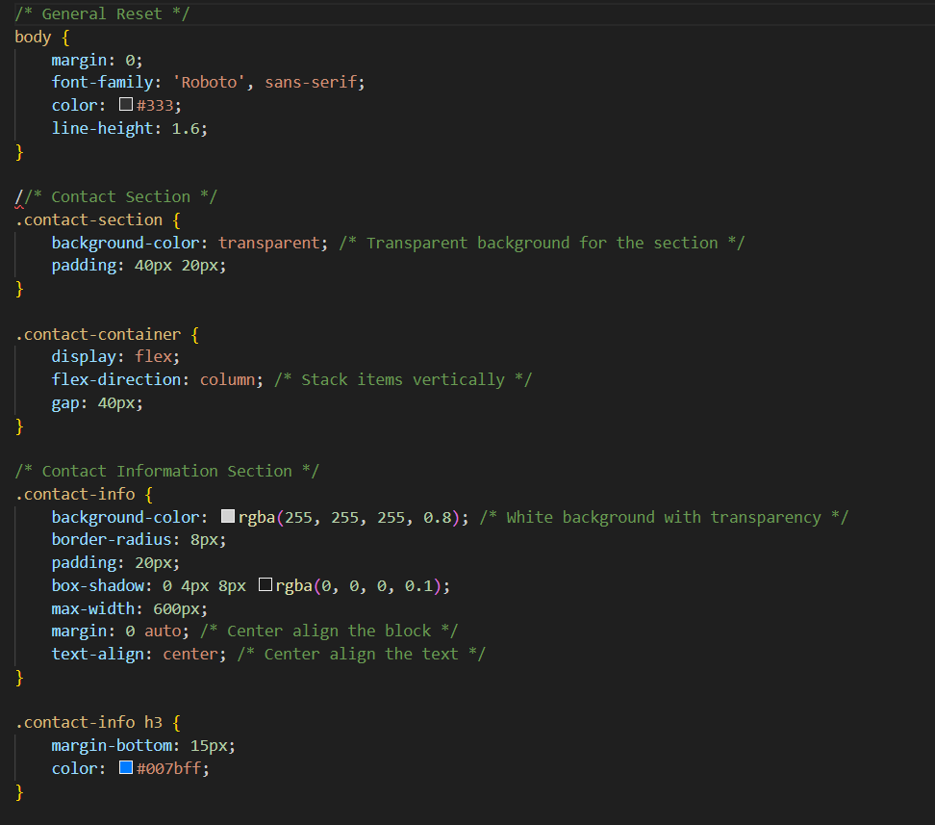

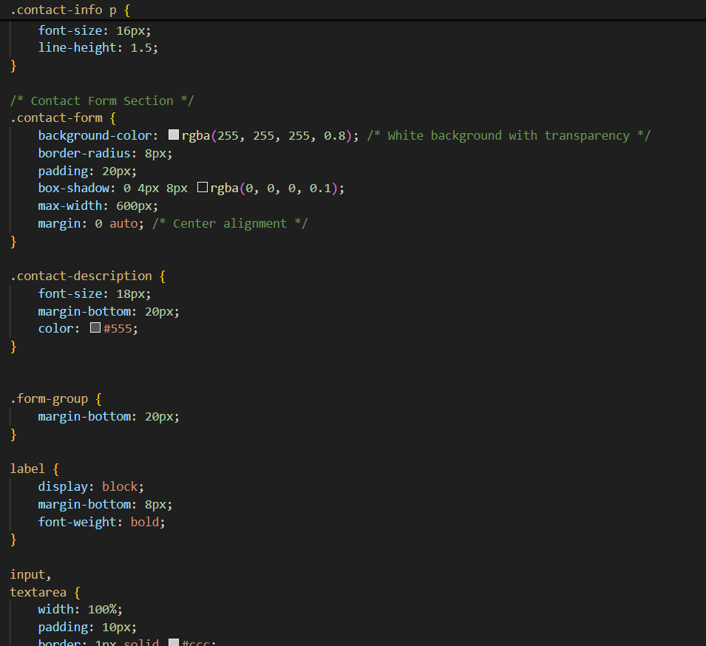

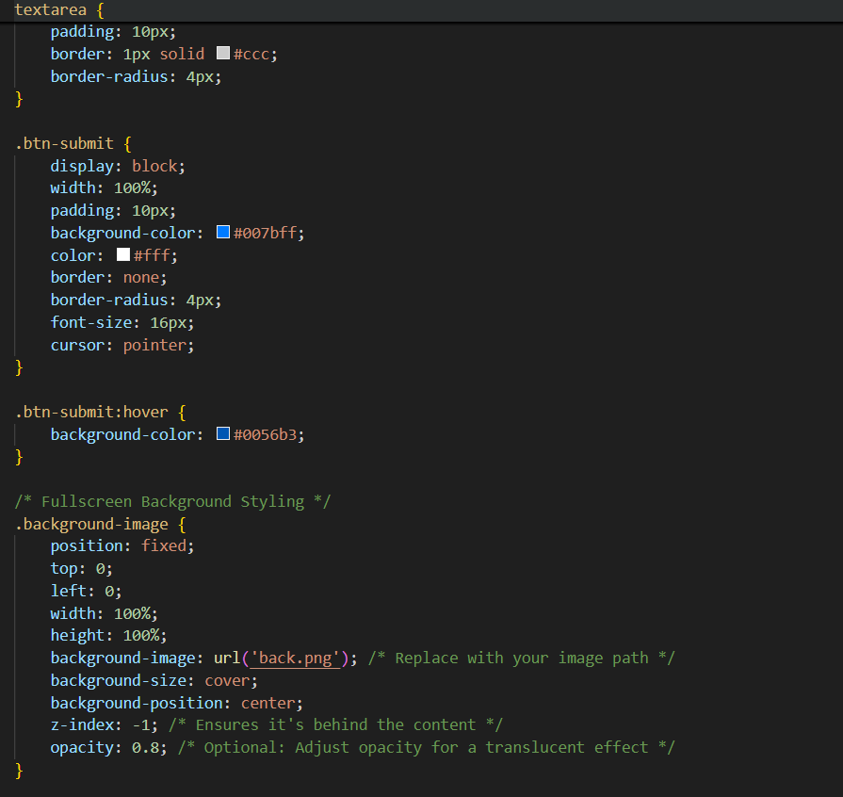

About us.html

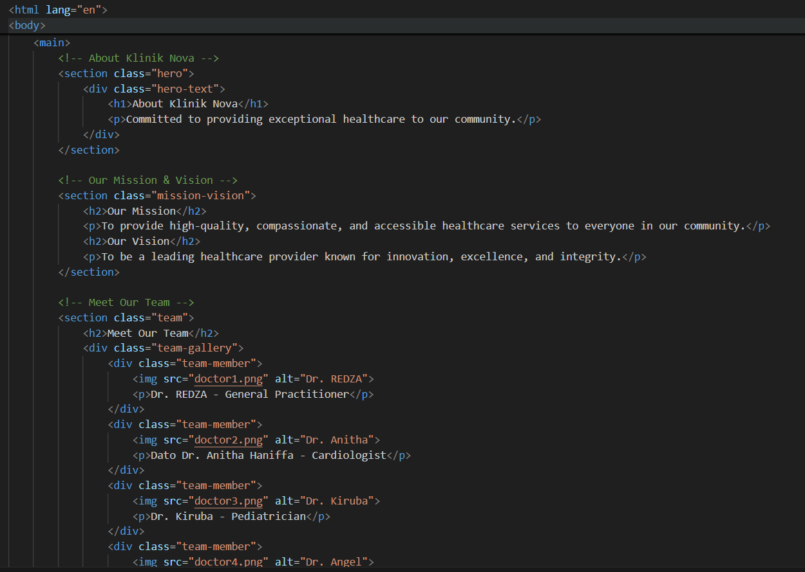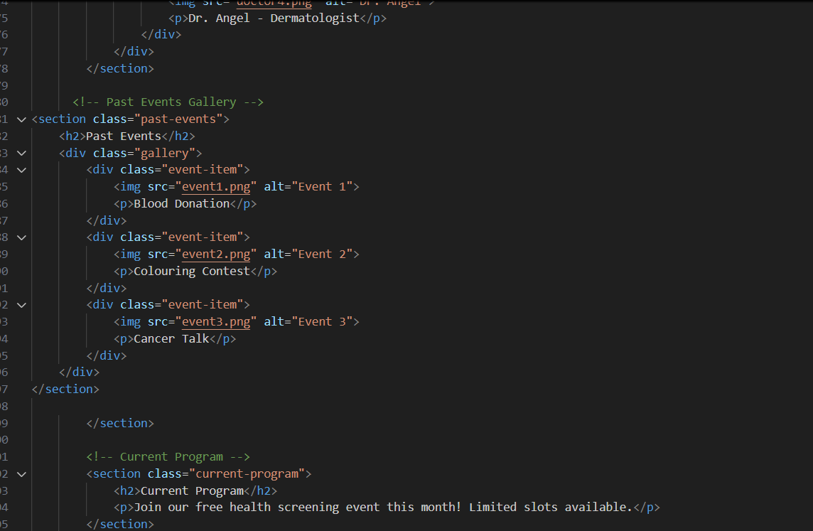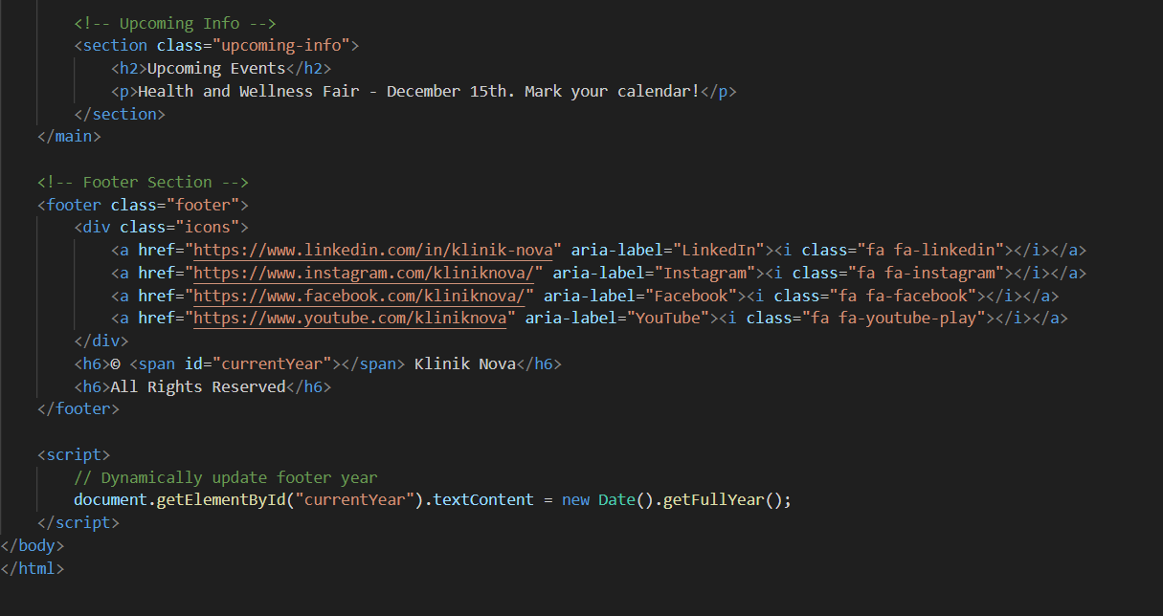

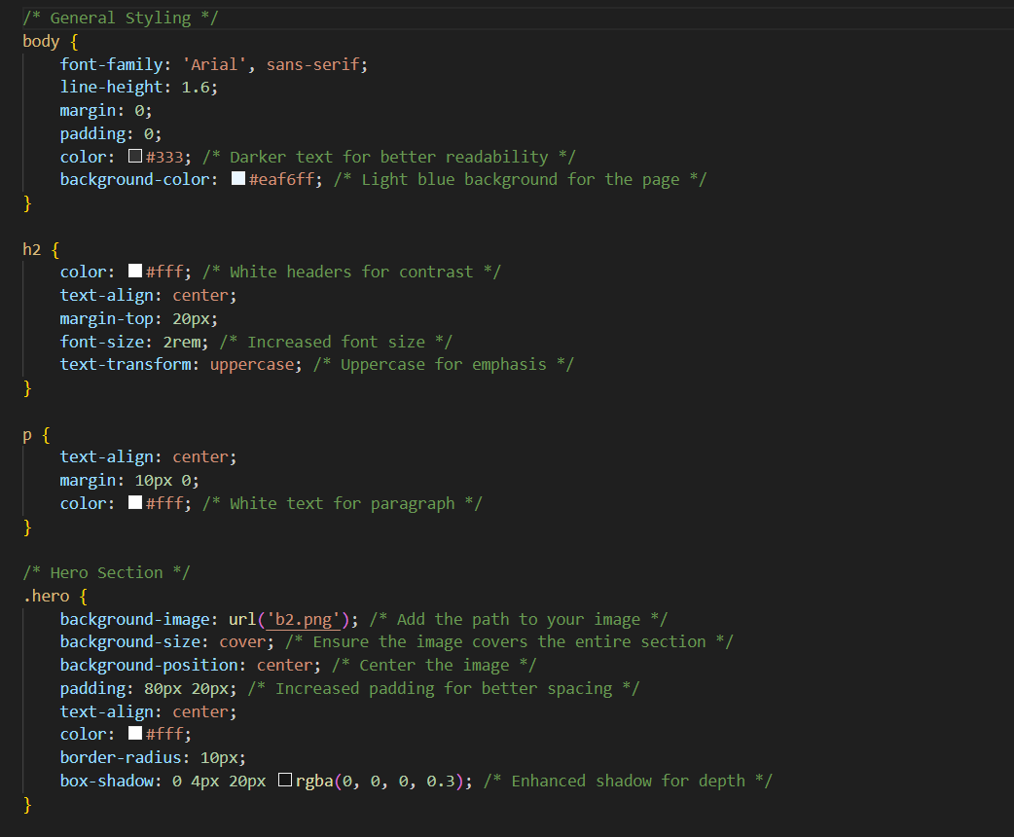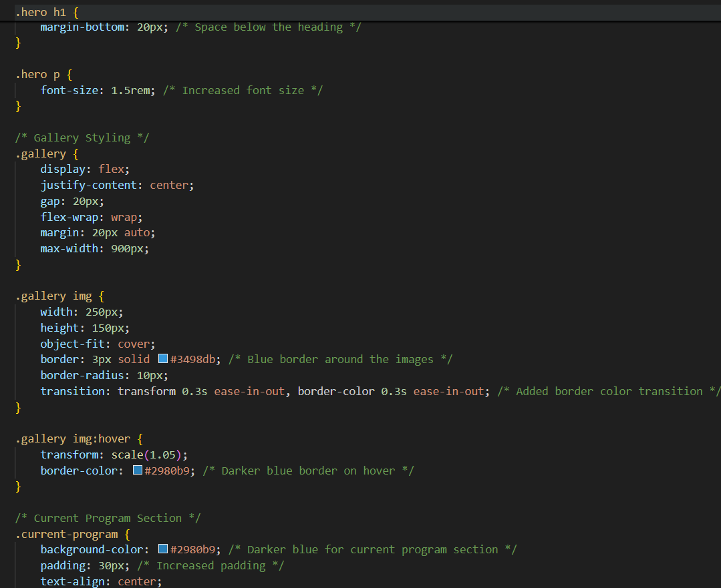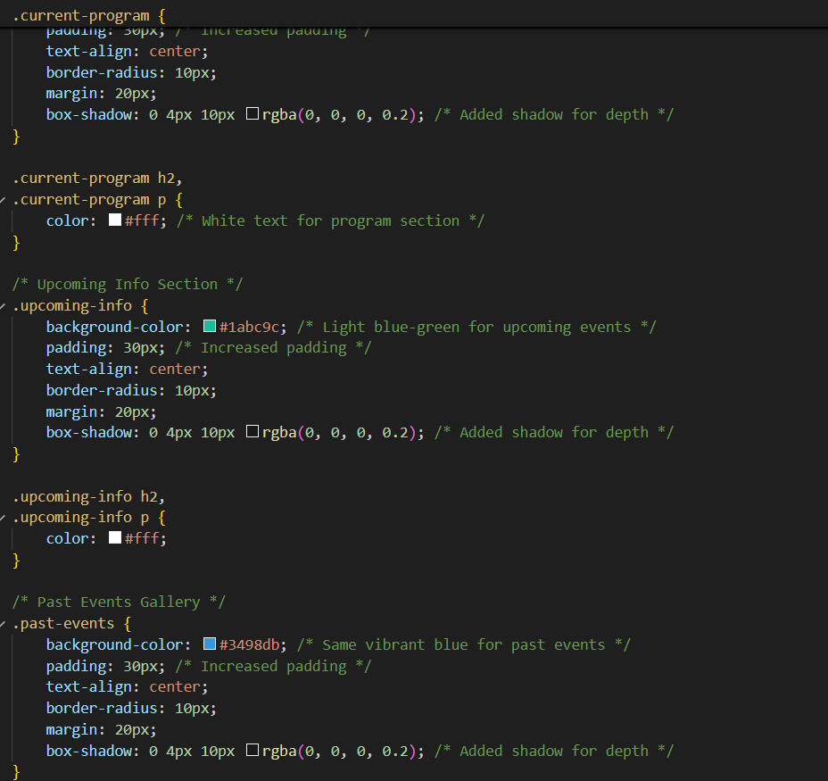

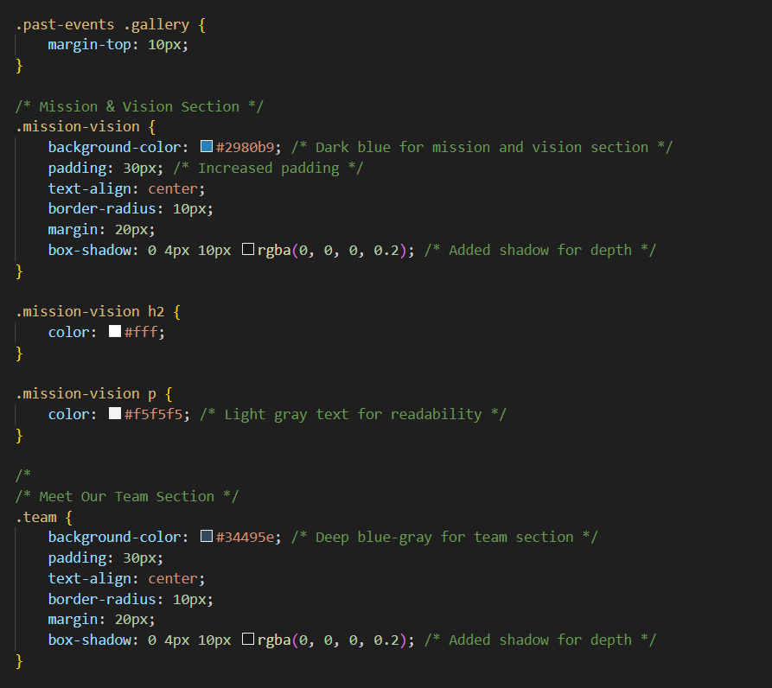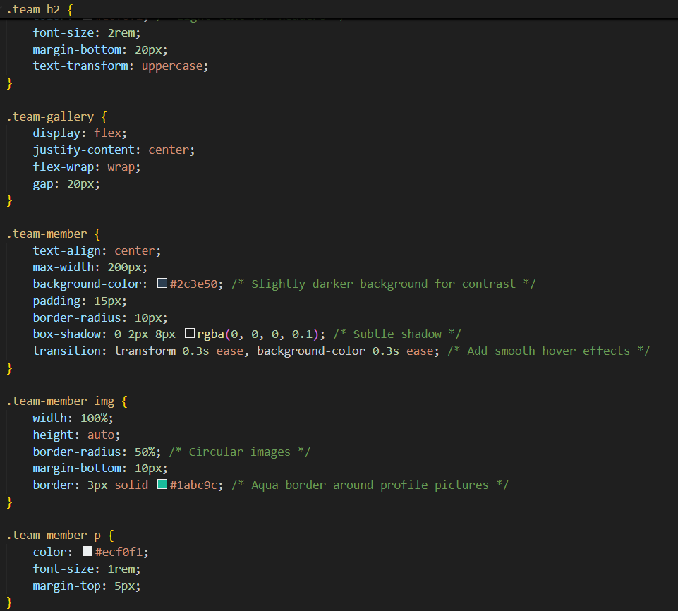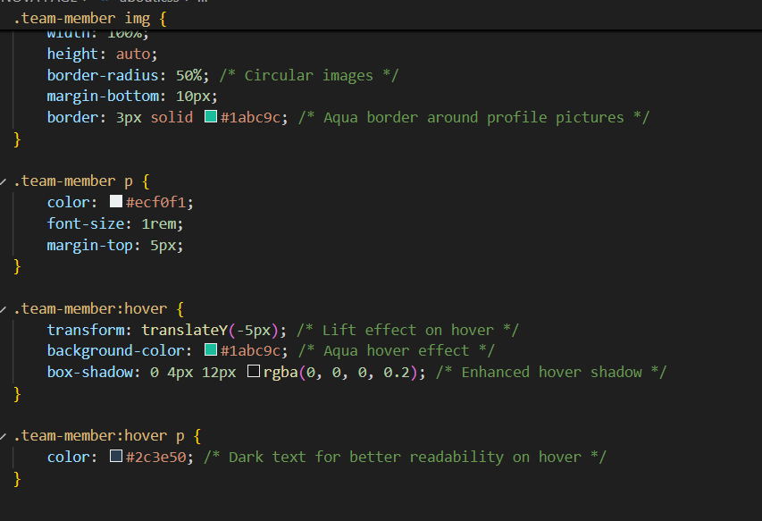

Signup.html

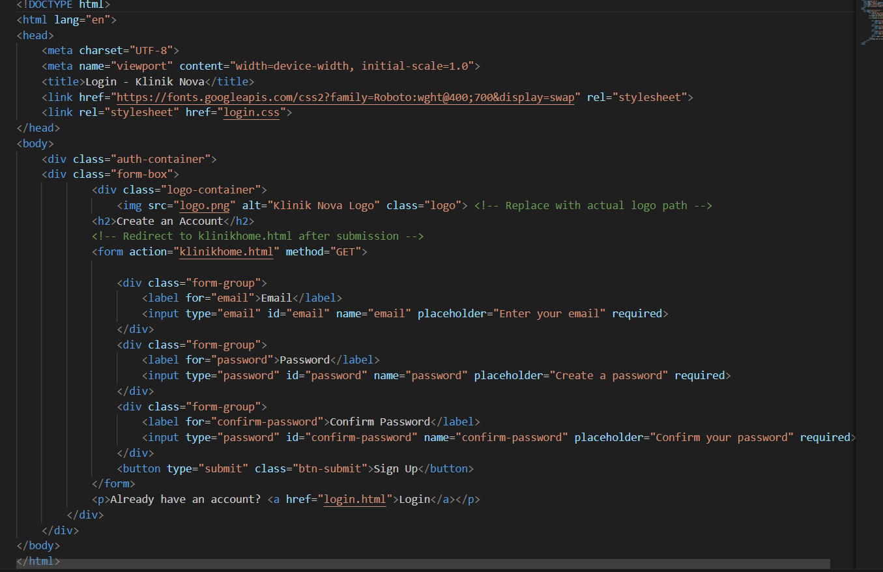

Logininpage.html

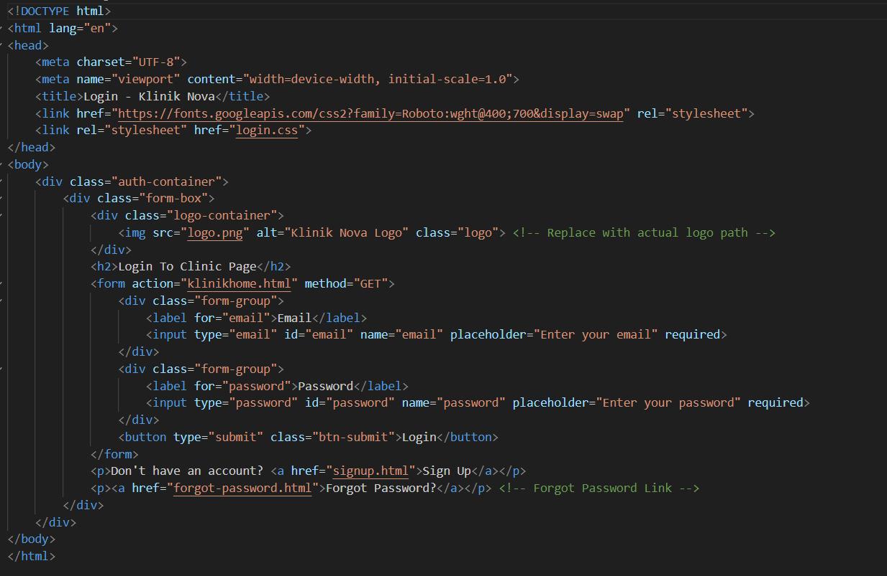

Login.css

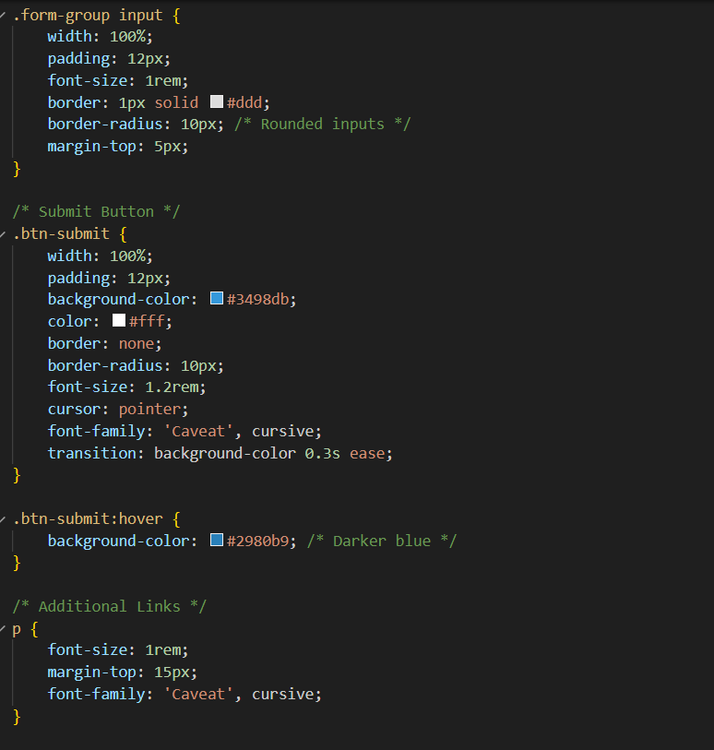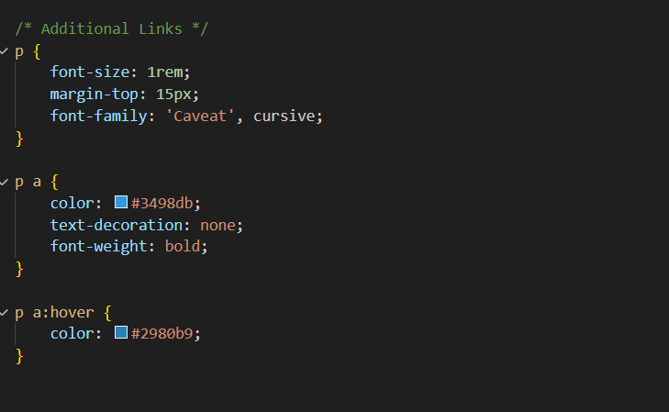

Forgetpassword.html

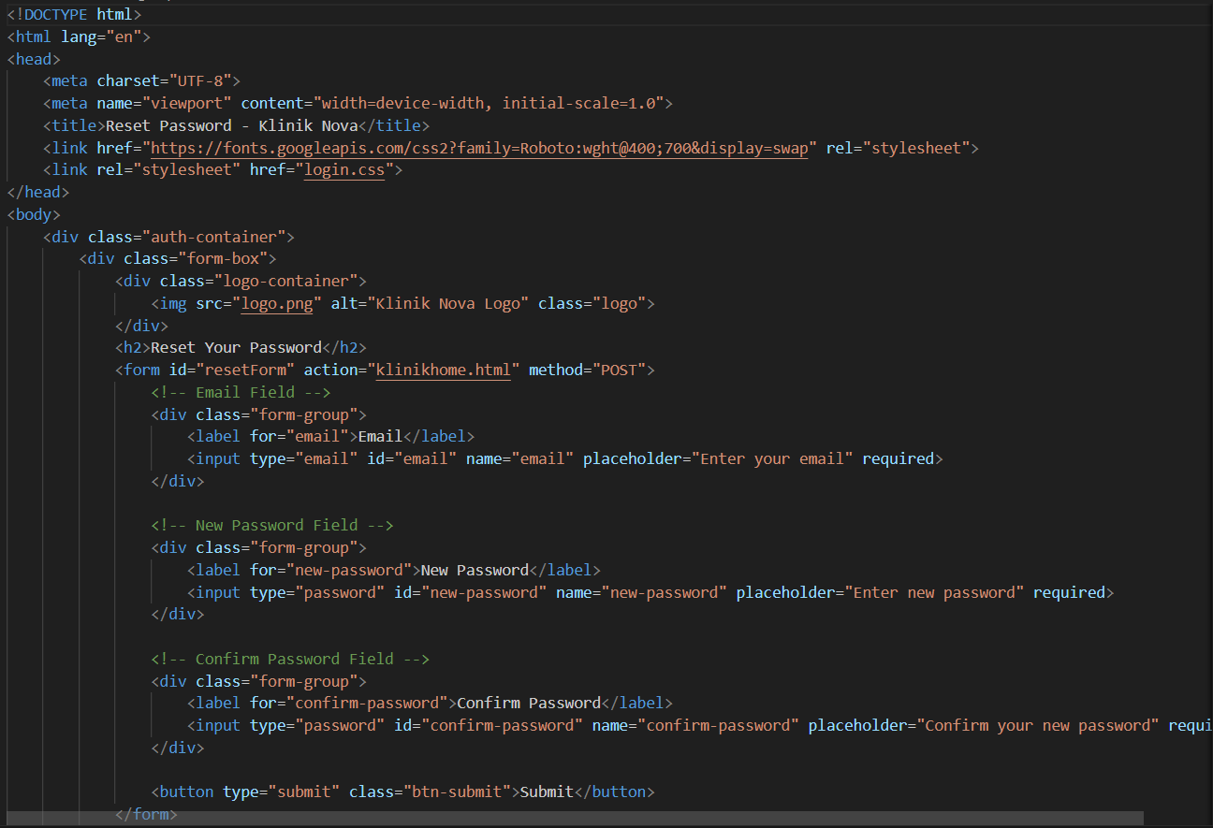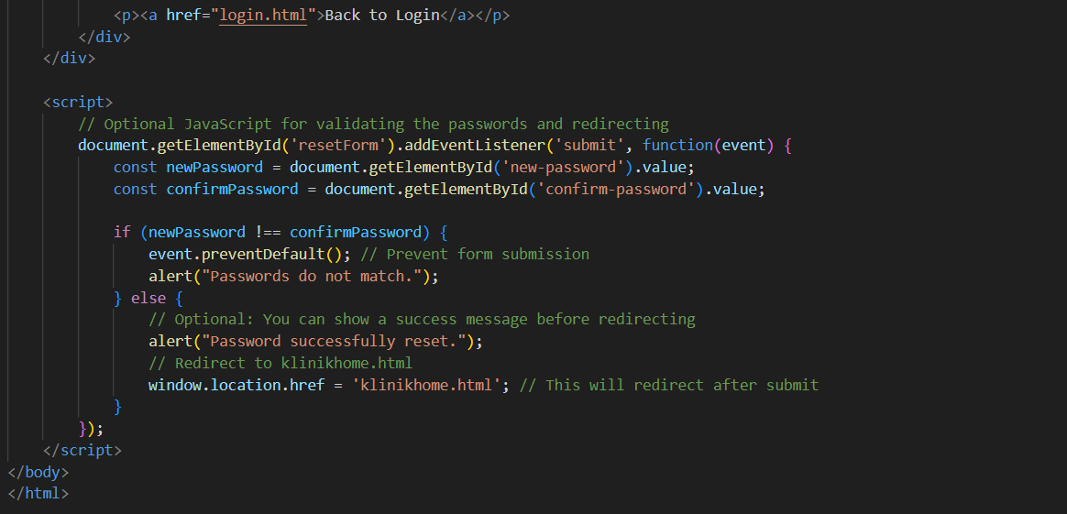

Admin and doctor

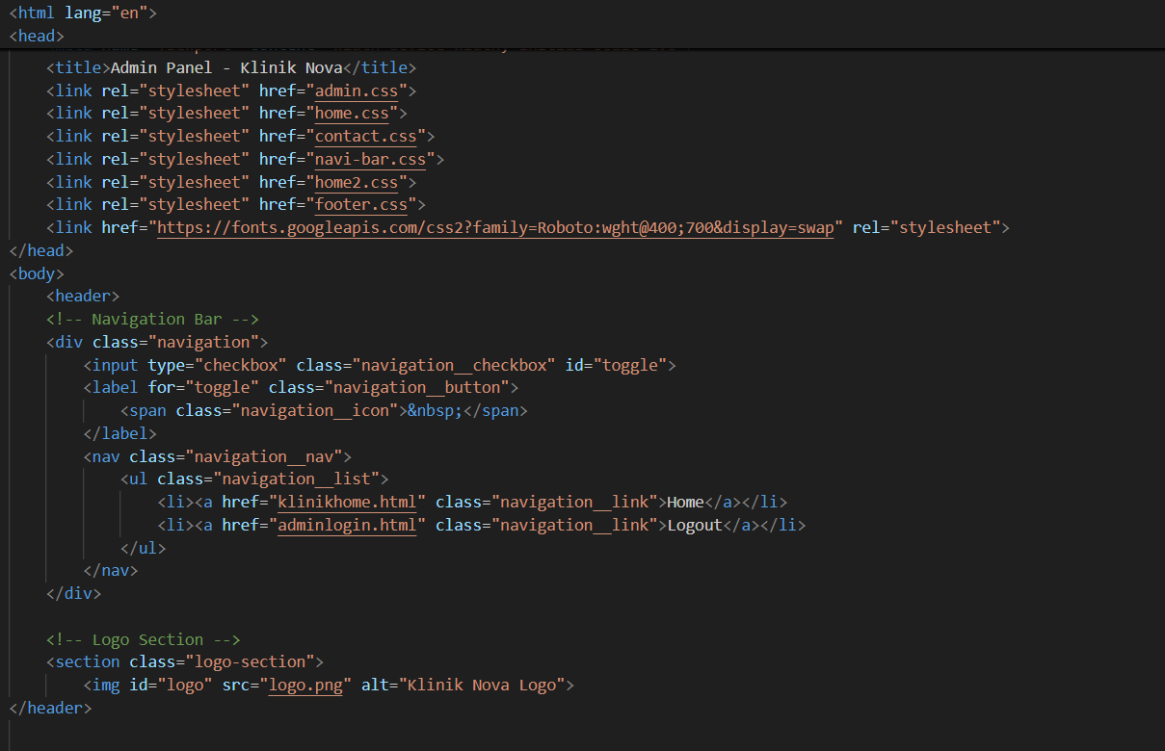

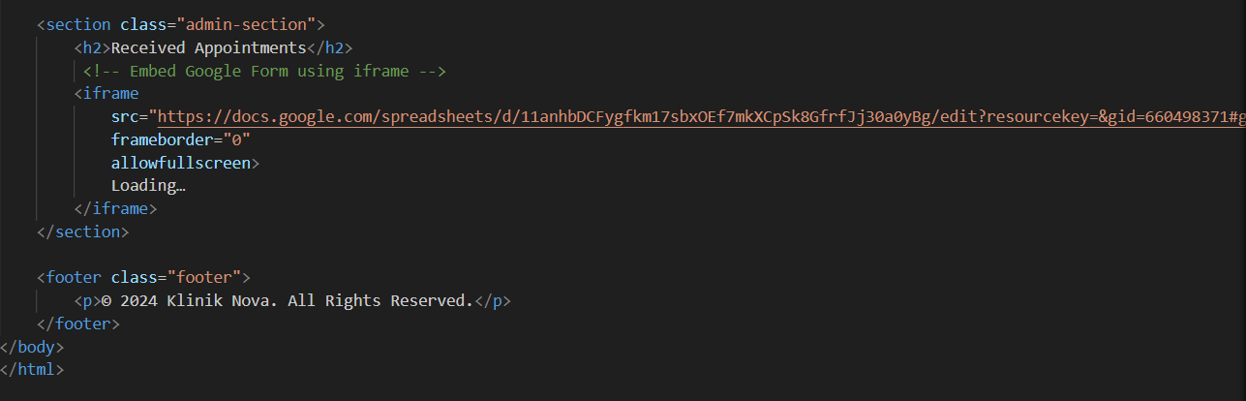

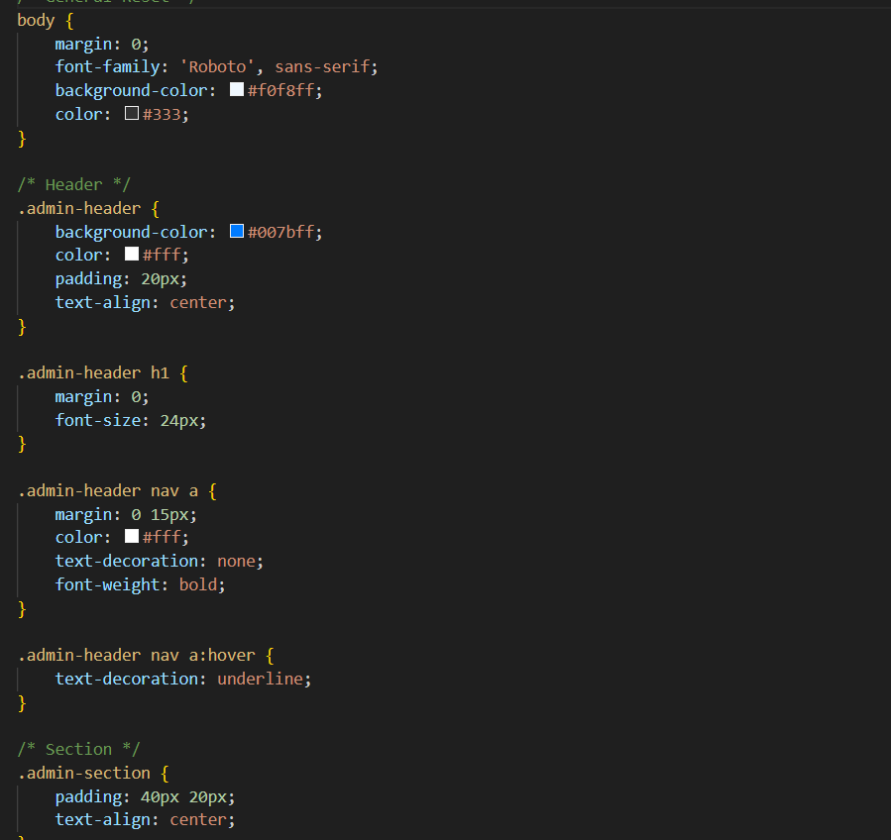

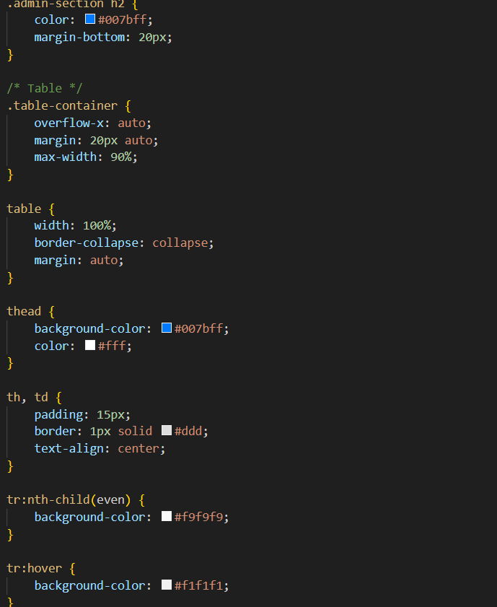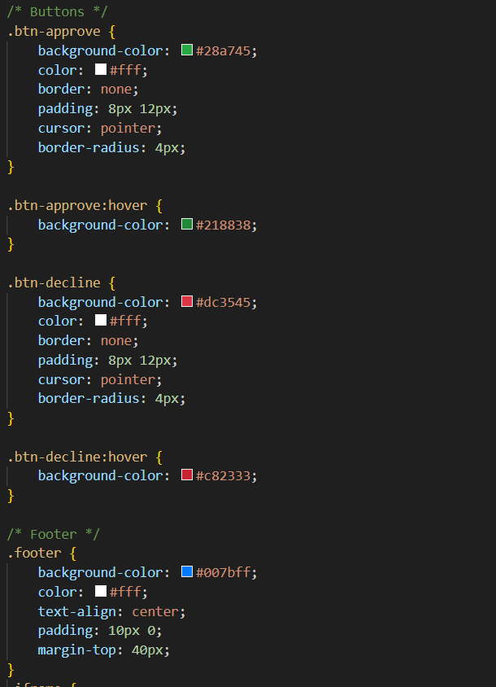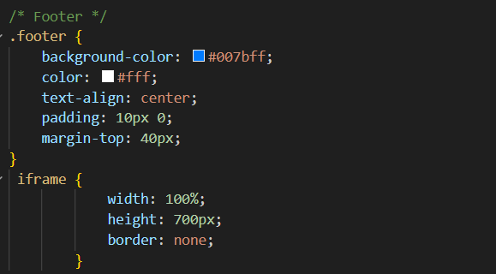

Adminloagin.html

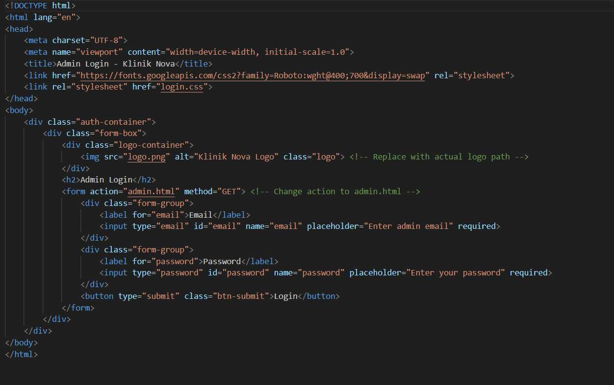

Adminlogin.css

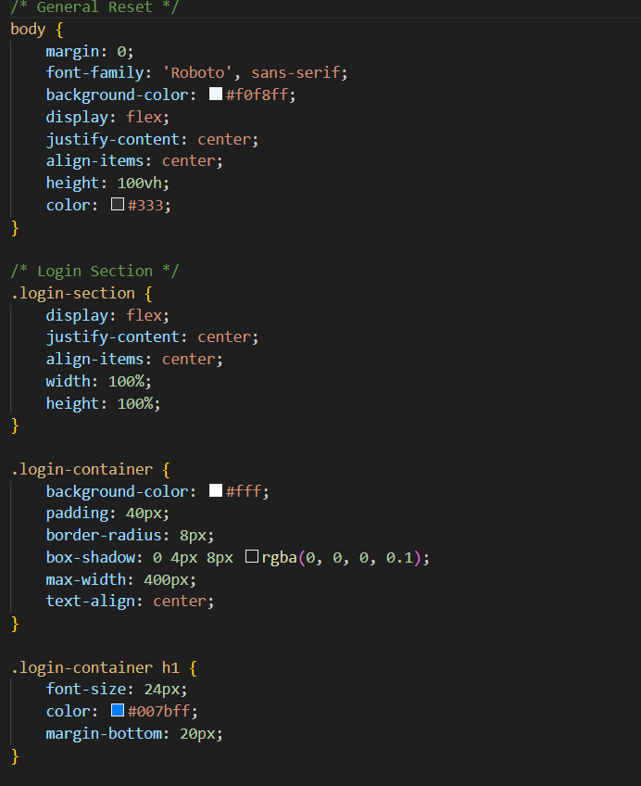

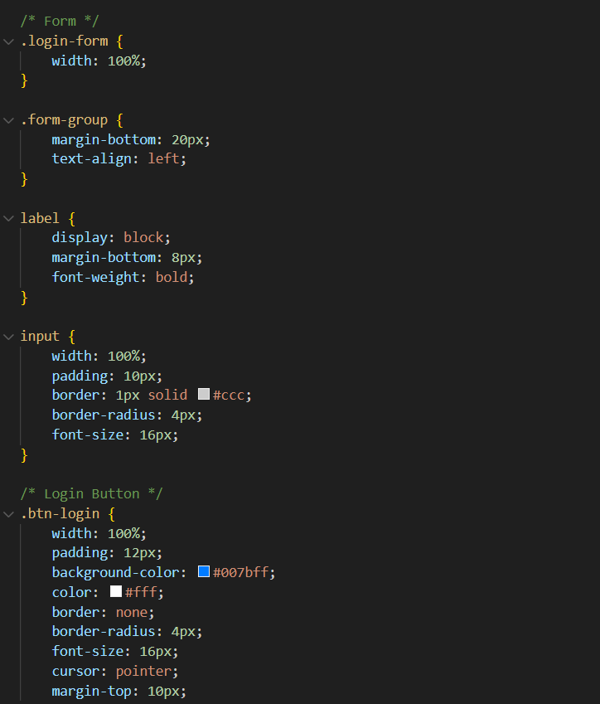

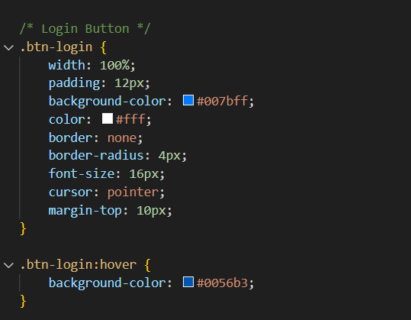

Appointment-hamdle.php

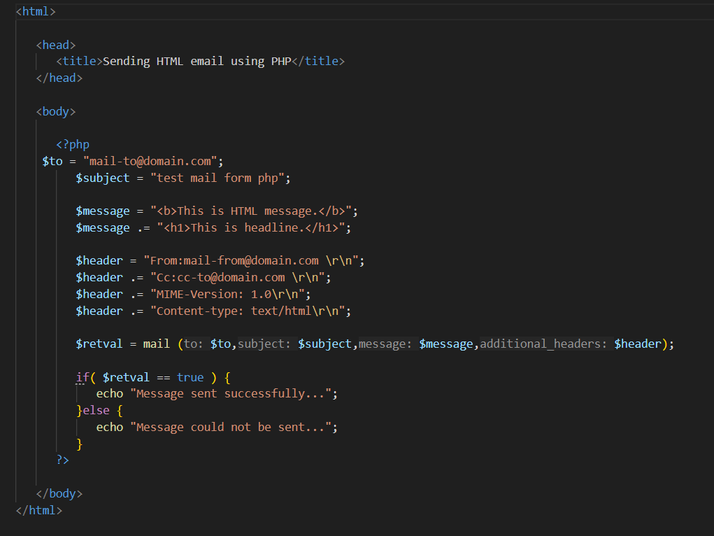

Mail.php

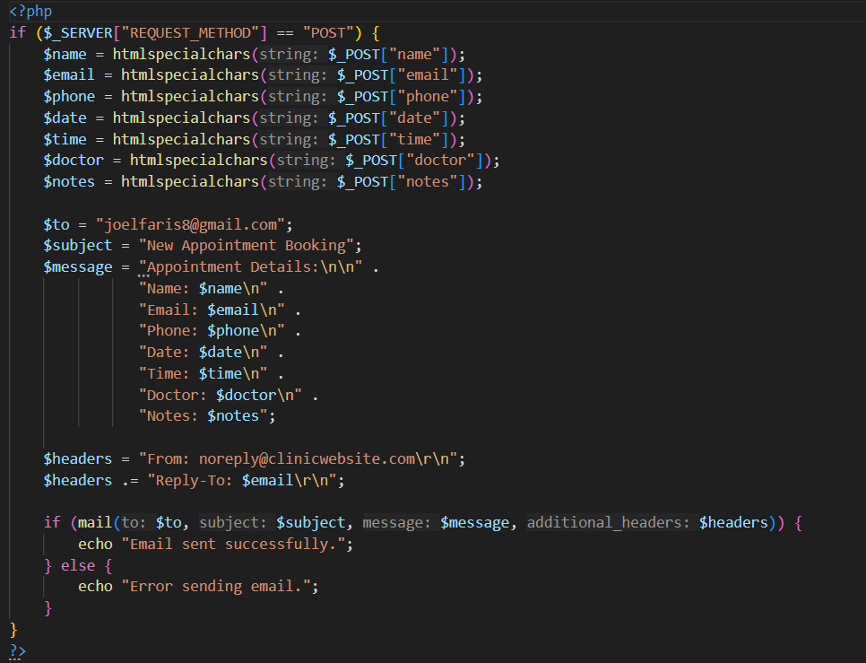

SCRIPT.js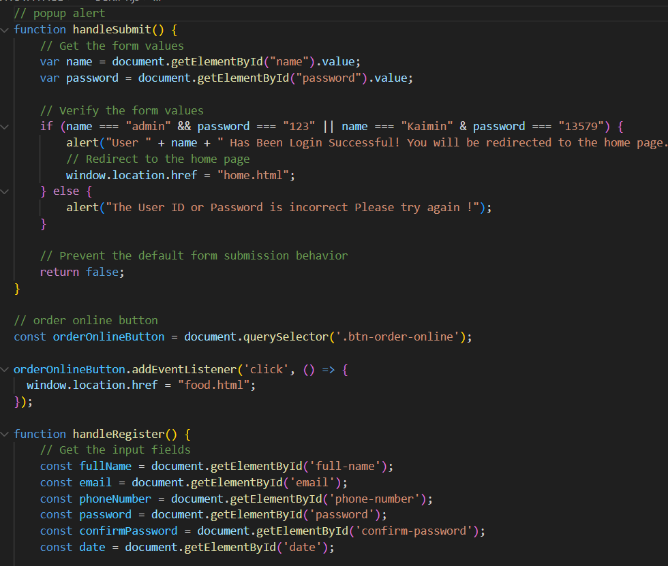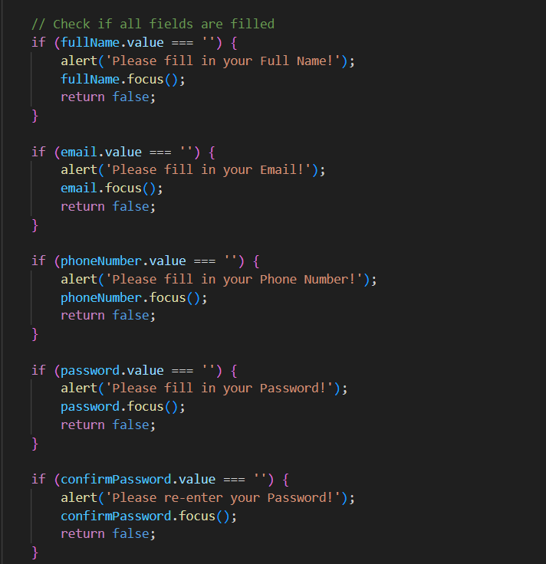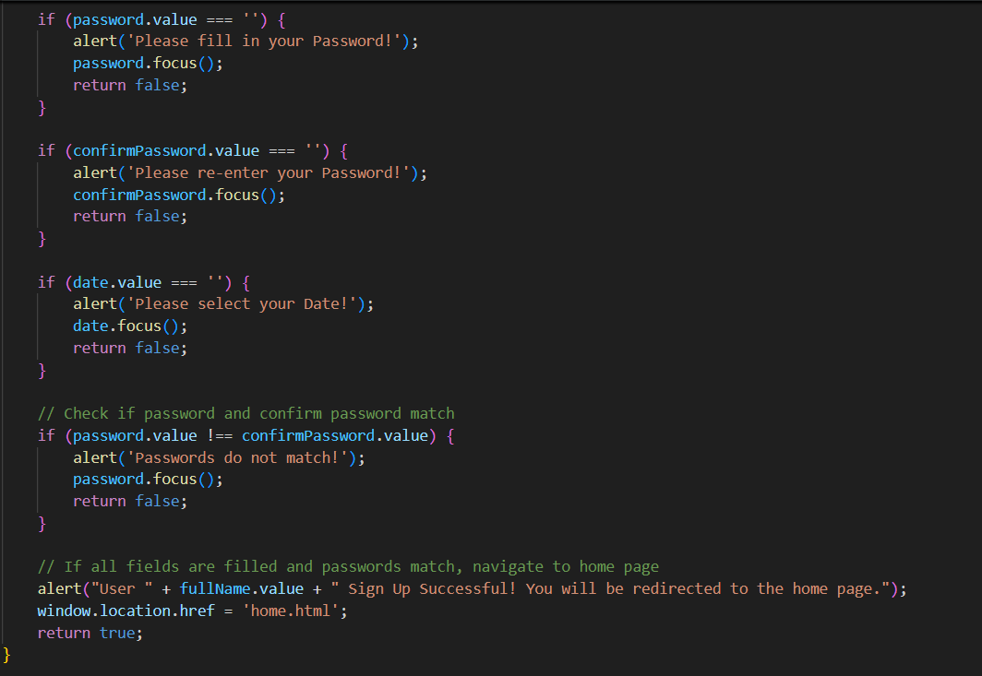

Sever.js

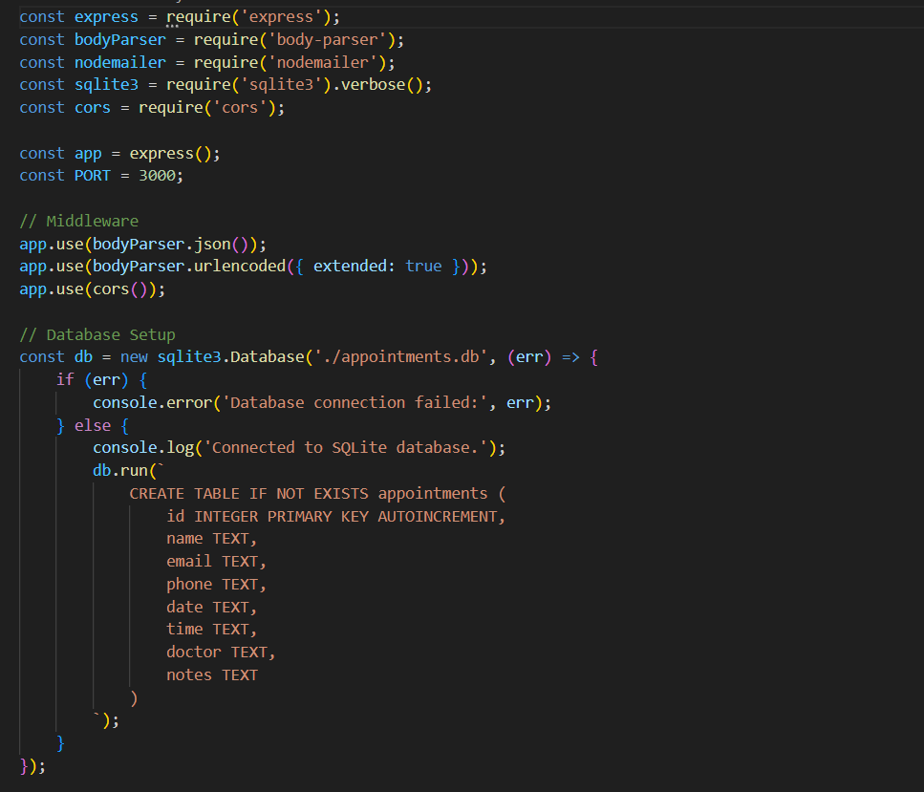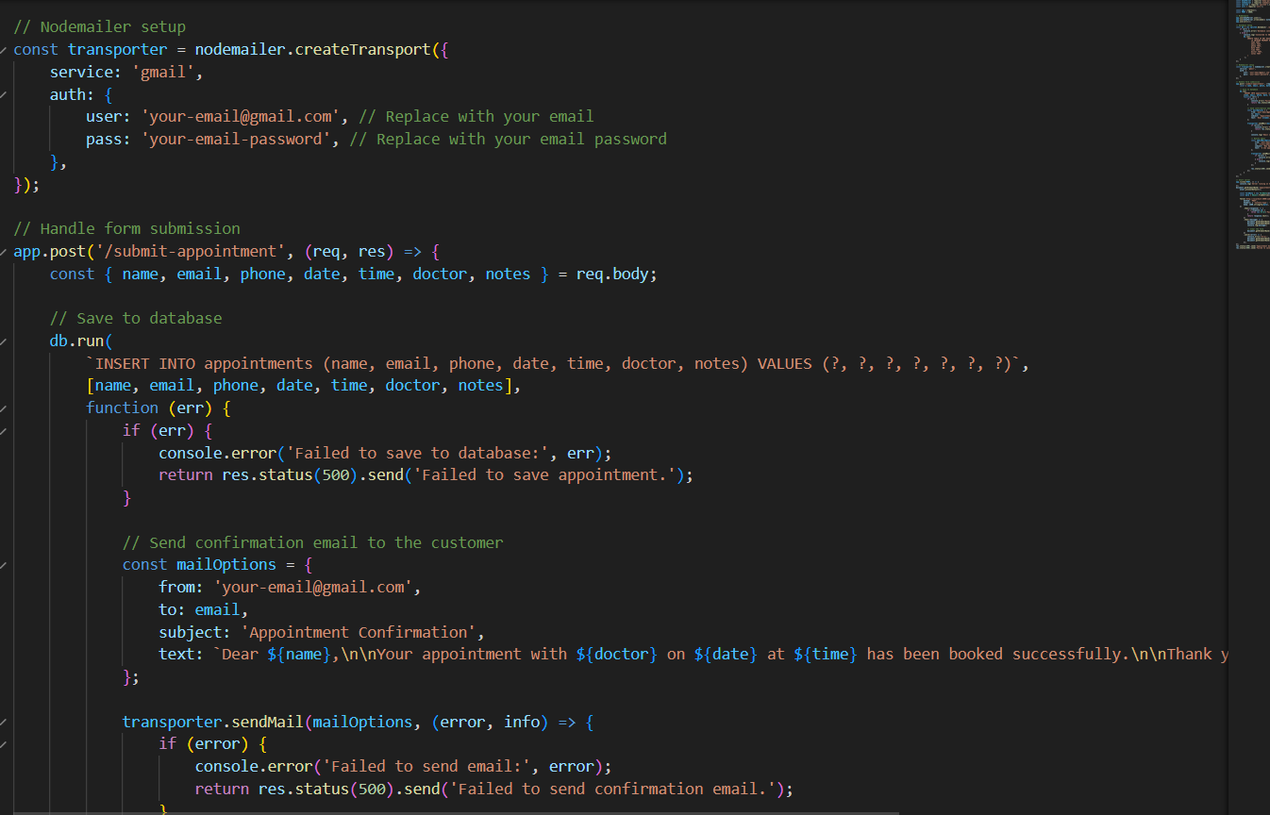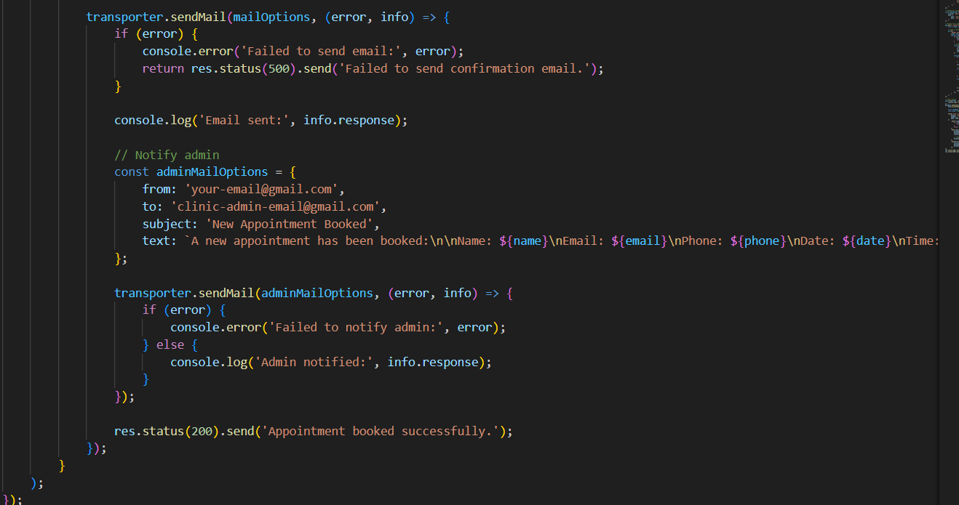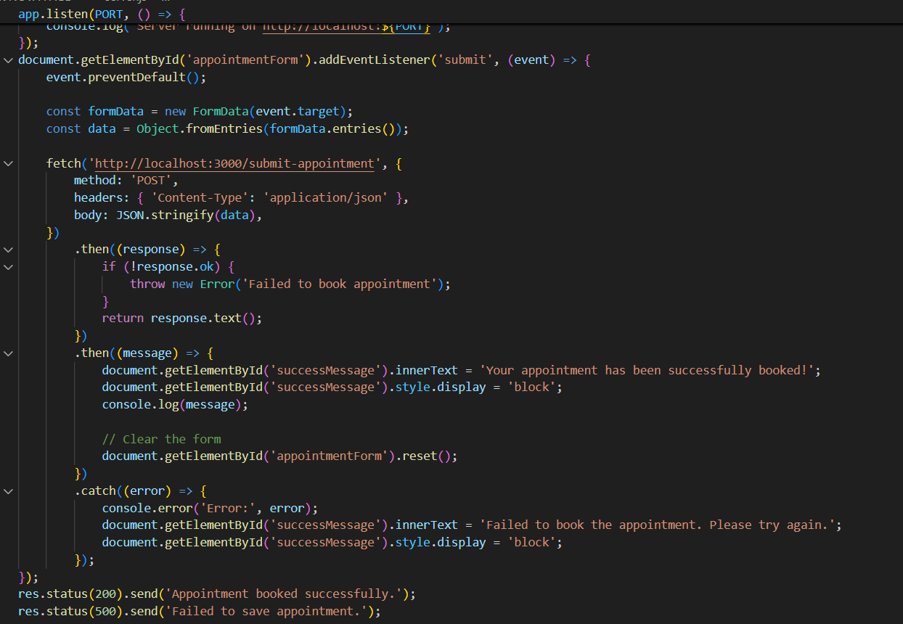

## 1.5.4. New features added or strengths of code

Patient to use:

Home page

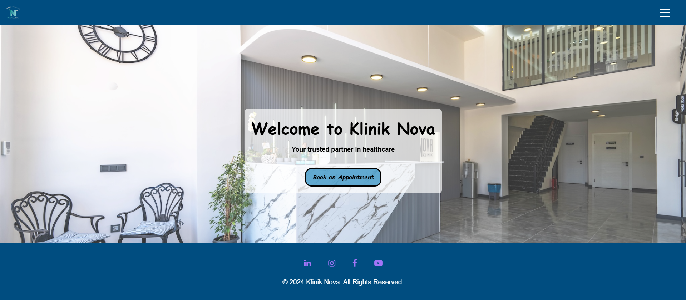

Choose the pages

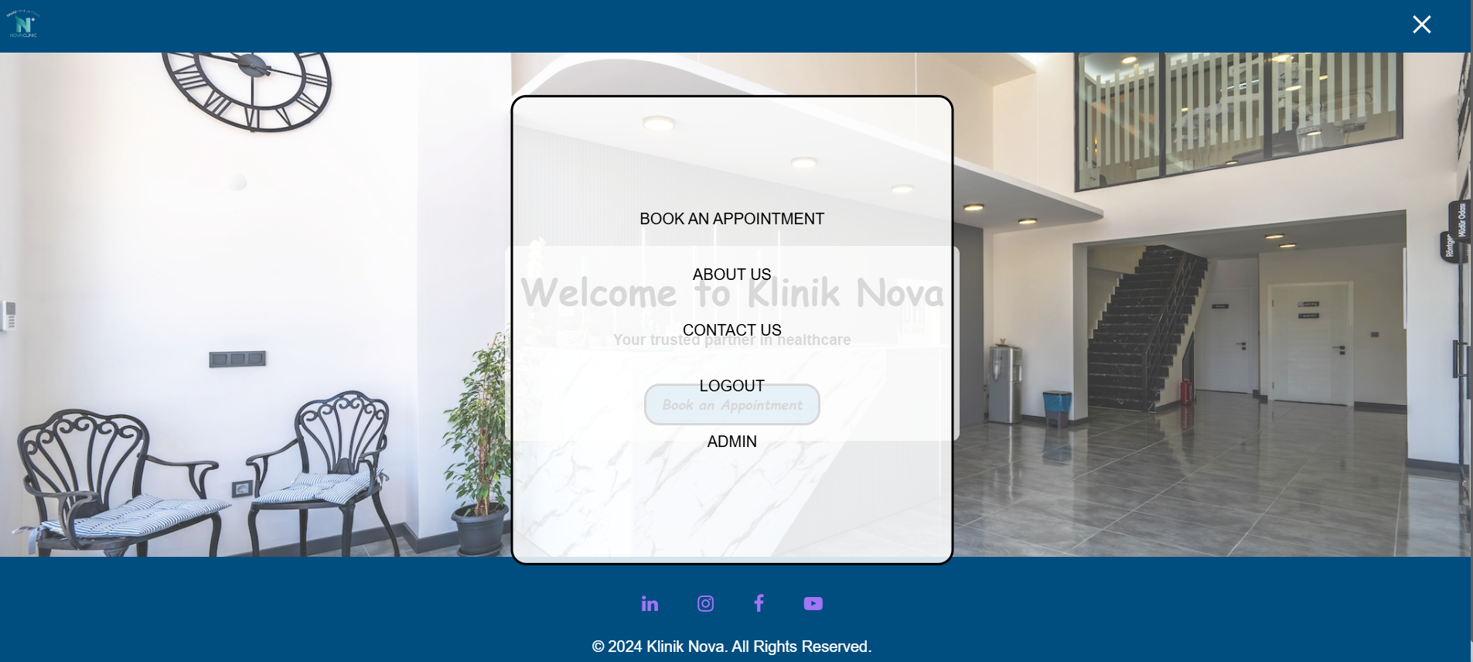

Appointment page

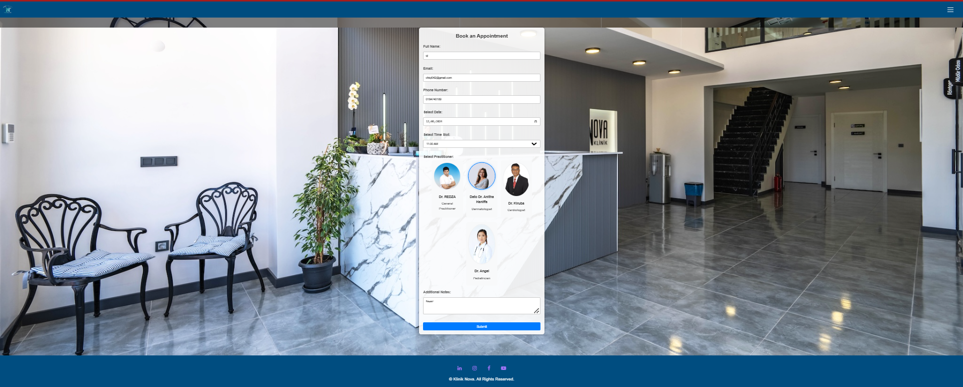

When you submit can come to this page

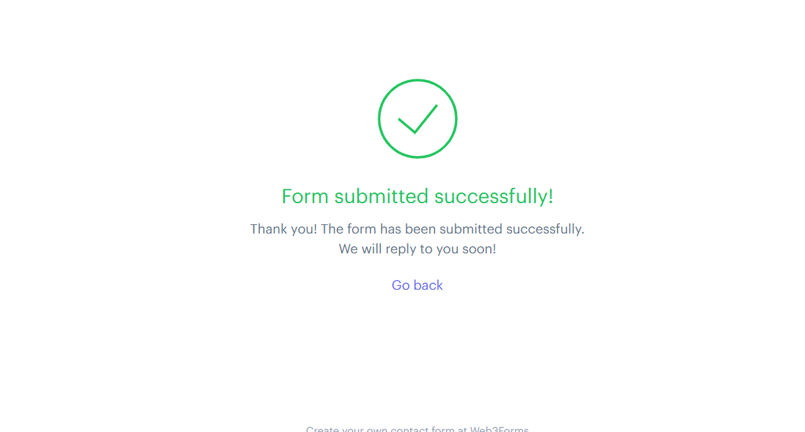

About Us pages

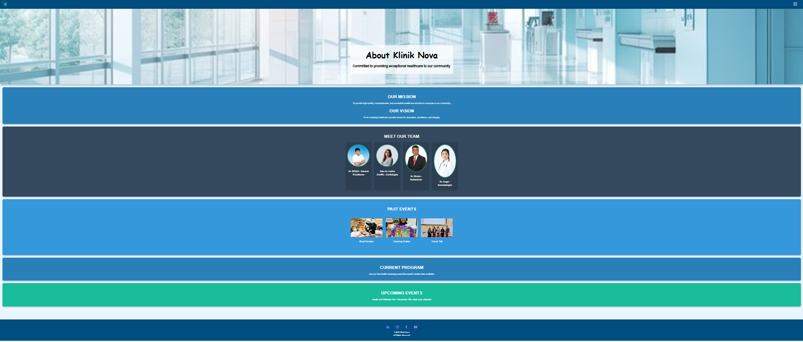

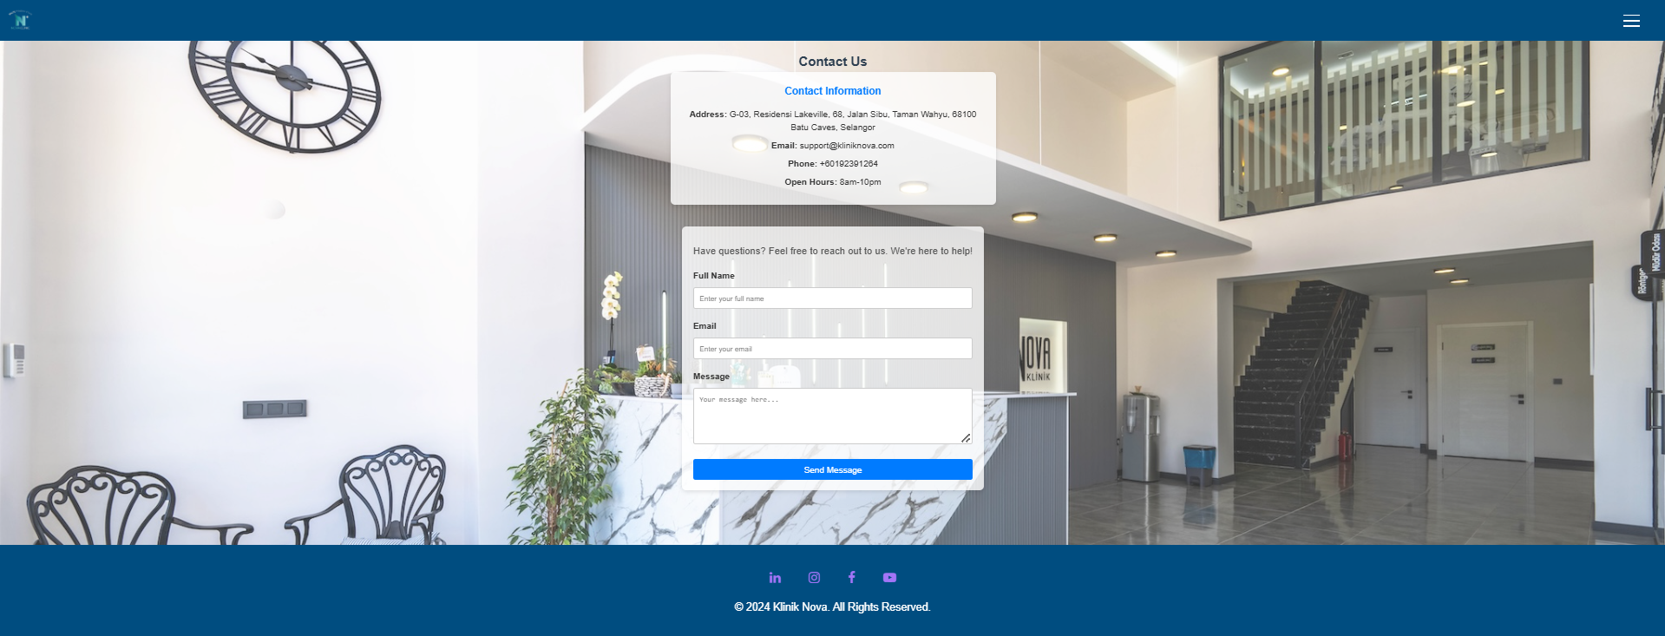

Login page of the patient

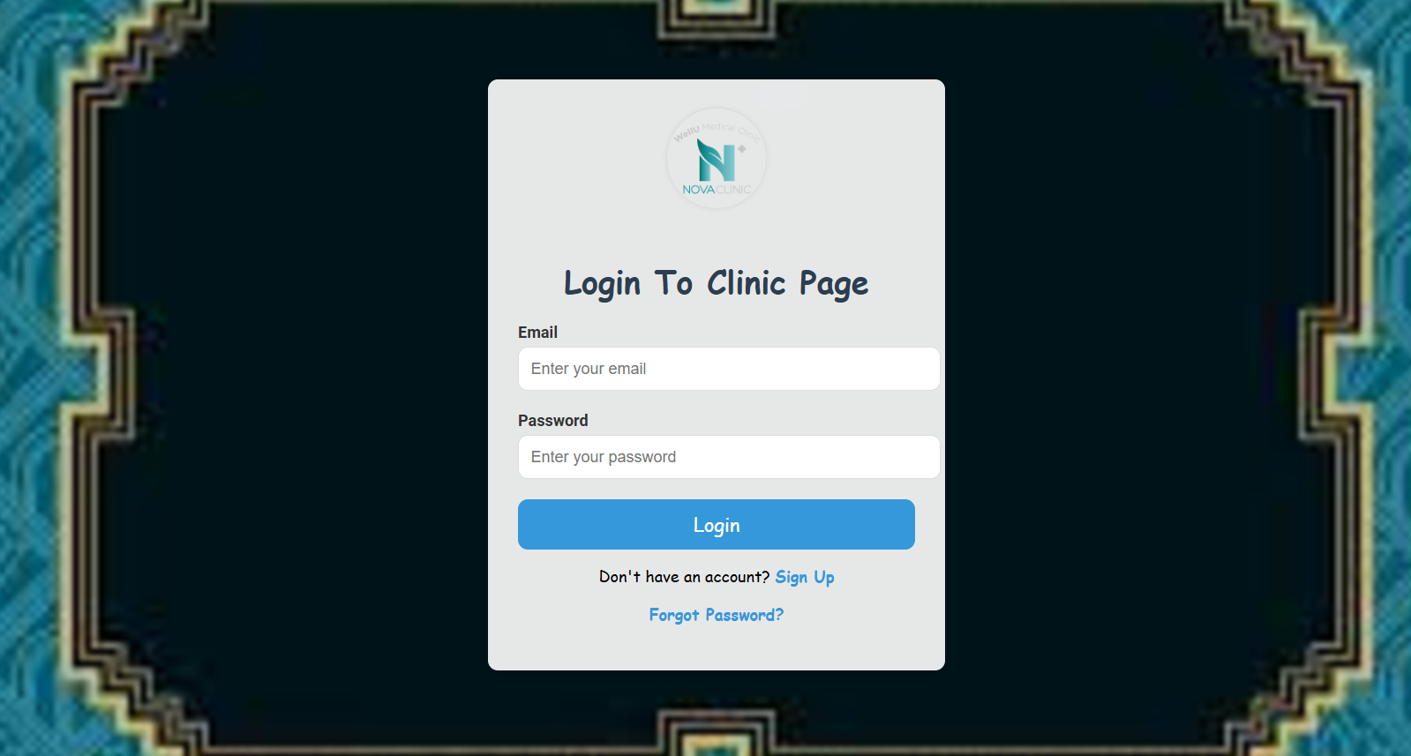

Sign Up of the patient

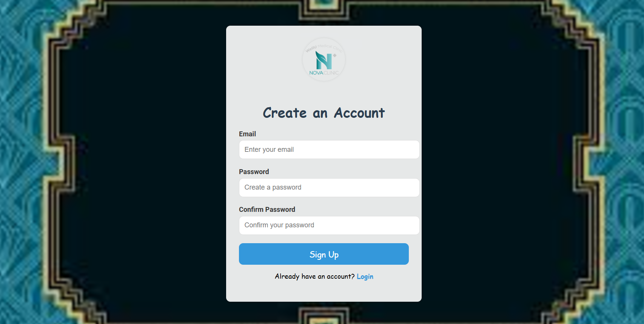

Forget Password Page 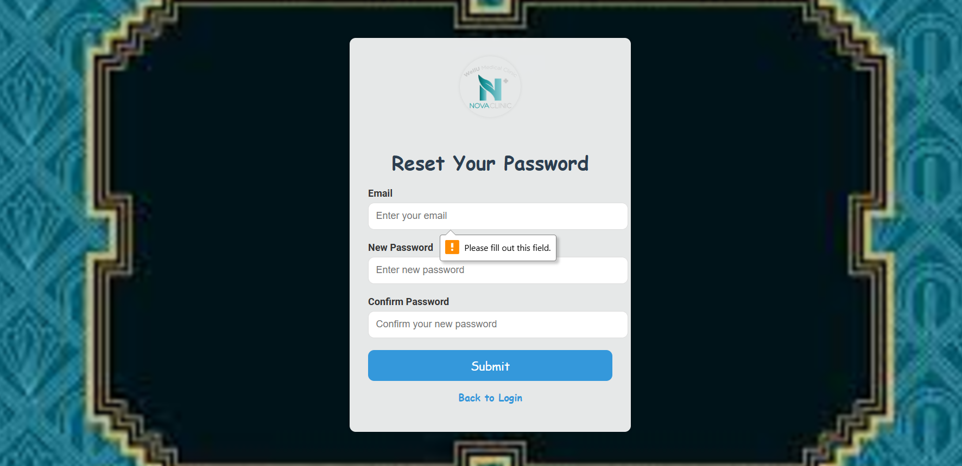

Admin and Doctor

Admin page

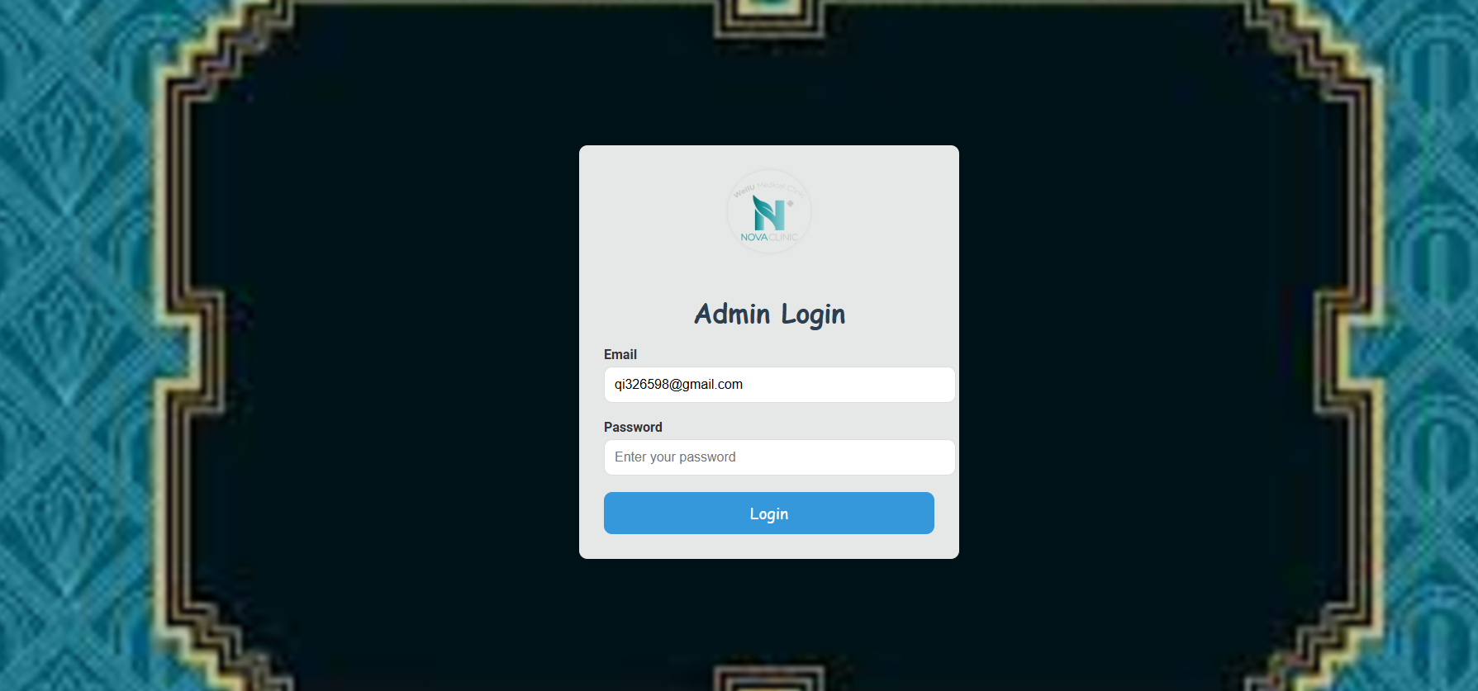

Received Appointment

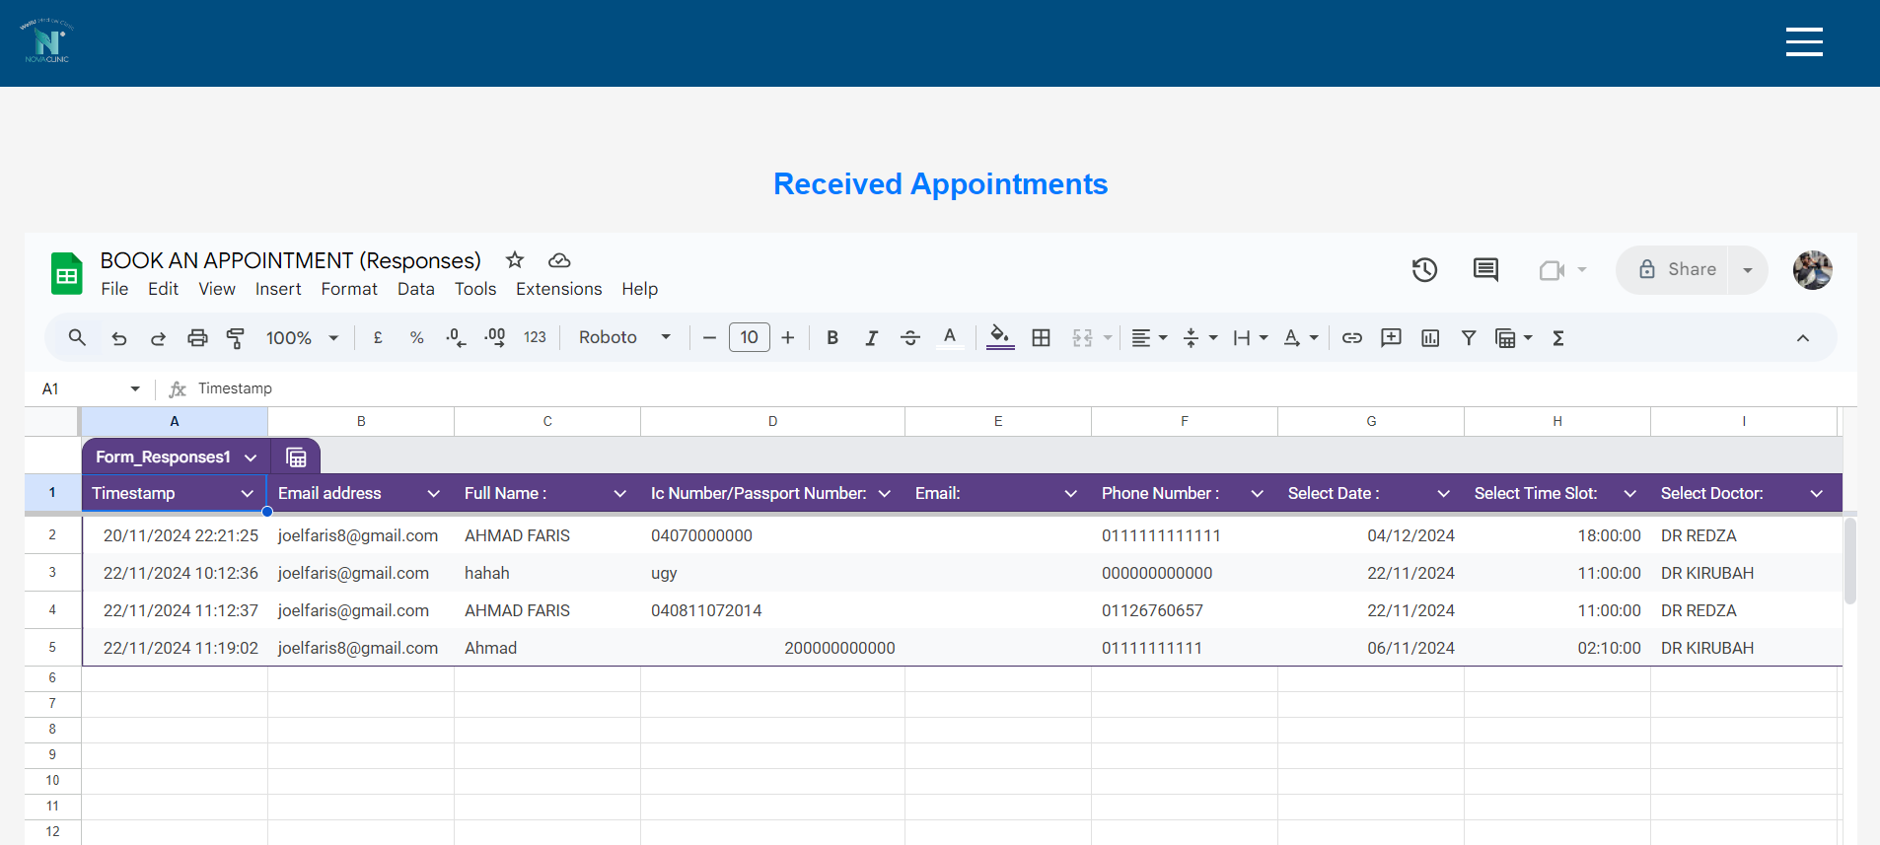

## 

## 1.5.5 Detail of any faults

**1. Form Validation Flaws**

* **Issue**: Users could submit forms with incomplete or invalid data, such as improperly formatted email addresses.
* **Root Cause**: The initial code lacked comprehensive validation rules.
* **Solution**: Enhanced JavaScript validation by implementing stricter checks and using regular expressions to validate email and phone number formats.

**2. Browser Compatibility Challenges**

* **Issue**: The website did not render correctly on certain browsers, especially older versions of Internet Explorer.
* **Root Cause**: The use of modern CSS and JavaScript features incompatible with older browsers.
* **Solution**: Introduced compatibility adjustments, added CSS fallbacks, and performed extensive cross-browser testing.

**3. Delayed Email Notifications**

* **Issue**: Email notifications sometimes exceeded the target processing time of 5 seconds.
* **Root Cause**: Server-side delays and reliance on external email services.
* **Solution**: Improved the email-sending process through asynchronous execution and configured a faster, more reliable SMTP server.

**4. Layout Issues on Mobile Devices**

* **Issue**: Form elements and buttons appeared misaligned or too small when viewed on smaller screens.
* **Root Cause**: Inadequate focus on responsive design during the initial development phase.
* **Solution**: Refined CSS media queries and adjusted layouts to improve usability and alignment for mobile users.

**5. Accessibility Limitations**

* **Issue**: The website lacked ARIA labels and proper keyboard navigation, reducing accessibility for some users.
* **Root Cause**: Accessibility considerations were not thoroughly integrated into the early design process.
* **Solution**: Added ARIA attributes, optimized keyboard navigation, and ensured compliance with Web Content Accessibility Guidelines (WCAG).

# 1.6 Conclusion

The creation of a one-page clinic landing page for appointment scheduling marks a meaningful advancement in tackling persistent issues related to patient-administrator communication, appointment management, and operational efficiency. These challenges, often tied to reliance on outdated, manual methods, result in delays, miscommunication, and administrative bottlenecks. This project aimed to resolve these issues by developing a user-friendly, accessible, and responsive digital solution tailored to the needs of both patients and clinic staff.

The platform introduces essential features such as intuitive navigation, real-time form validation, and a responsive interface to deliver a seamless booking experience for patients. Moreover, it ensures clinic administrators promptly receive detailed and accurate booking information via email, enabling them to effectively manage schedules and resources. By integrating these functionalities, the system not only optimizes appointment scheduling but also fosters improved communication and operational efficiency within the clinic.

The project successfully addressed its functional goals, including secure user registration, instant appointment confirmation, and interactive form validation to guide users throughout the booking process without errors. Equally important were the non-functional requirements, such as performance optimization, robust security protocols, system reliability, and adherence to web accessibility standards, all of which were carefully implemented to enhance the platform’s overall quality, usability, and inclusivity.

Security was a central focus, with measures like HTTPS encryption and trusted email servers ensuring that sensitive user data remained protected. Performance improvements ensured that form submissions and email notifications were processed within seconds, providing users with a reliable and efficient experience. Furthermore, compliance with web accessibility standards ensured the platform could be used by individuals with disabilities, broadening its usability and impact.

This project highlights the transformative potential of technology in healthcare operations, particularly in streamlining processes like appointment scheduling, which significantly influence both patient satisfaction and clinic performance. By simplifying administrative tasks while maintaining high standards of data security and user experience, the platform demonstrates how digital tools can effectively address real-world challenges.

Looking ahead, the platform serves as a robust foundation for further enhancements. Features such as automated patient reminders via email or SMS, data analytics for tracking booking trends, and calendar synchronization could enhance its functionality. Additionally, integrating multilingual support and expanding accessibility features could make the platform even more inclusive and adaptable to diverse user needs.

In summary, this project exemplifies the importance of utilizing modern web technologies to address operational challenges in the healthcare sector. The collaborative efforts in designing, developing, and implementing this one-page clinic landing page have resulted in a responsive, reliable, and efficient solution that meets current needs while laying the groundwork for future innovations. This experience underscores the critical role of innovation, teamwork, and iterative development in achieving meaningful and sustainable outcomes.

# 1.7Peer Review

Name: LEE CHI QI

Scale: 1 - Poor, 5 - Excellent

|  |  |  |  |
| --- | --- | --- | --- |
| No. | Criteria | (Me)Member Name:  LEE CHI QI | Member Name:  Ahmad Faris Bin Mohamad Asri |
| 1 | How would you rate the overall contribution of this team member to the assignment? | 4 | 5 |
| 2 | How effectively did this team member complete the tasks assigned to them? | 3 | 4 |
| 3 | How well did this team member collaborate and communicate with others? | 3 | 5 |
| 4 | How well did this team member contribute to problem-solving during the assignment? | 4 | 4 |
| 5 | How would you assess this team member's attitude and professionalism throughout the project? | 4 | 4 |
| 6 | Overall, how much did this team member contribute to the success of the project? | 4 | 5 |

Yes/No; Provide examples

|  |  |  |  |
| --- | --- | --- | --- |
| No. | Criteria | (Me)Member Name:  LEE CHI QI | Member Name:  Ahmad Faris Bin Mohamad Asri |
| 1 | Did this team member actively participate in team meetings and discussions? | Yes | Yes |
| 2 | Did this team member meet the deadlines for their tasks? | Yes | Yes |
| 3 | Was this team member open to feedback and willing to adjust their work? | Yes | Yes |
| 4 | Did this team member show initiative by suggesting new ideas or improvements for the assignment? | Yes | Yes |

Name: Ahmad Faris

|  |  |  |  |
| --- | --- | --- | --- |
| No. | Criteria | (Me)Member Name:  AHMAD FARIS BIN MOHAMED ASRI | Member Name:  LEE CHI QI |
| 1 | How would you rate the overall contribution of this team member to the assignment? | 4 | 5 |
| 2 | How effectively did this team member complete the tasks assigned to them? | 4 | 5 |
| 3 | How well did this team member collaborate and communicate with others? | 4 | 5 |
| 4 | How well did this team member contribute to problem-solving during the assignment? | 4 | 5 |
| 5 | How would you assess this team member's attitude and professionalism throughout the project? | 5 | 5 |
| 6 | Overall, how much did this team member contribute to the success of the project? | 4 | 5 |

Yes/No; Provide examples

|  |  |  |  |
| --- | --- | --- | --- |
| No. | Criteria | (Me)Member Name:  AHMAD FARIS BIN MOHAMED ASRI | Member Name:  LEE CHI QI |
| 1 | Did this team member actively participate in team meetings and discussions? | Yes | Yes |
| 2 | Did this team member meet the deadlines for their tasks? | Yes | Yes |
| 3 | Was this team member open to feedback and willing to adjust their work? | Yes | Yes |
| 4 | Did this team member show initiative by suggesting new ideas or improvements for the assignment? | Yes | Yes |

LEE CHI QI(SCPG2300150)

Introduction  
This project provided an opportunity to enhance my understanding of developing a clinic's appointment management system, a critical tool to address inefficiencies in patient scheduling and communication. The aim was to create a streamlined, user-friendly one-page landing page that allowed patients to book appointments easily while ensuring clinic administrators received real-time notifications. This system sought to improve appointment coordination and provide enhanced user experience for both patients and administrators.

Analysis  
To tackle the challenges faced by the clinic, we incorporated essential features such as user registration, appointment scheduling, email notifications, and responsive design. My primary contributions involved developing the registration and appointment forms using HTML, CSS, JavaScript and PHP while ensuring input validations for seamless user interactions. I also worked on integrating email notifications using a backend service, ensuring clinic administrators received booking details promptly. Team collaboration was critical in overcoming challenges like handling cross-browser compatibility and optimizing the system's performance.

Learning Outcomes  
This project taught me valuable lessons in team collaboration, system design, and user experience. I deepened my understanding of responsive web design principles and security measures, such as securing user data with HTTPS, CSS and PHP. Additionally, I gained practical experience in integrating real-time email notifications and testing the system across devices and appointments of PHP.

Conclusion  
In conclusion, the project highlighted the importance of digital solutions in solving real-world problems, such as appointment scheduling inefficiencies. Our teamwork and dedication resulted in a functional, aesthetically pleasing, and responsive system that significantly enhances the clinic's operational efficiency. This experience has reinforced the value of collaboration and iterative development in achieving project goals.

Ahmad Faris (scpg2300056)

**Overview**

This project provided an invaluable opportunity to delve into the creation of an appointment management system tailored for a clinic. It addressed the crucial need for streamlining patient scheduling and communication, two areas that often suffer from inefficiencies in many healthcare settings. The primary objective was to develop a user-friendly, visually appealing one-page landing page to simplify the appointment booking process for patients while ensuring real-time notifications for clinic administrators. This system aims to enhance scheduling efficiency, minimize administrative workload, and improve the overall user experience for both patients and clinic staff.

Our approach emphasized usability and accessibility, ensuring that even users with limited technical proficiency could navigate the system effortlessly. Additionally, we prioritized responsive design to cater to users across various devices, such as smartphones, tablets, and desktops. By integrating real-time email notifications, the system ensures that clinic administrators remain promptly informed of new bookings, enabling them to manage appointments effectively.

**Analysis**

We included necessary functionality including user registration, appointment scheduling, email notifications, and responsive design to address the clinic's problems. Creating the registration and appointment forms with HTML, CSS, JavaScript, and PHP while making sure that input validations were in place to ensure smooth user interactions was my main contribution. To guarantee that clinic administrators received booking details in a timely manner, I also worked on integrating email notifications utilizing a backend service. In order to overcome obstacles like managing cross-browser compatibility and maximizing the system's efficiency, teamwork was essential.

**Learning Outcomes**

I learned a lot about user experience, system design, and teamwork from this project. I gained a deeper understanding of security precautions, such using HTML, CSS, JavaScript and PHP to secure user data, and responsive site design ideas. Furthermore, I had hands-on expertise with PHP Mailer-Master, testing the system across devices, and implementing real-time email notifications, and LICENCES.

**Conclusion**

This project underscored the transformative power of digital solutions in addressing real-world challenges like inefficient appointment scheduling. Through collaboration, innovation, and dedication, we developed a responsive, visually appealing, and highly functional appointment management system that significantly improves the clinic's operational efficiency.

The success of this project highlights the importance of teamwork, iterative development, and user-centered design in achieving technical objectives. It also reinforced the need for continuous learning and adaptation in the fast-evolving field of technology.

Looking ahead, this experience serves as a solid foundation for future endeavors in developing user-focused digital tools, emphasizing the potential of technology to drive meaningful change in everyday operations.

# References

* Duckett, J. (2011). *HTML and CSS: Design and Build Websites*. Wiley.
* Frain, B. (2015). *Responsive Web Design with HTML5 and CSS3*. Packt Publishing.
* W3C Web Accessibility Initiative. (2018). *Web Content Accessibility Guidelines (WCAG) 2.1*. Retrieved from <https://www.w3.org/WAI/>.